Task 1: Create one IAM user and assign EC2 and S3 full access roles.
Objective
Create an IAM user in AWS, provide AWS Management Console access using a password, and grant full access permissions to Amazon EC2 and Amazon S3 services.

Prerequisites
- AWS Account with administrative privileges.
- Access to the AWS Management Console.

Step 1: Open IAM Service
- Log in to the AWS Management Console.
- Search for IAM (Identity and Access Management) in the search bar.
- Open the IAM dashboard.
- From the left navigation pane, select Users.
- Click Create User.

Step 2: Create IAM User
User Details
Enter the following:
User name: ec2-s3-admin
Click Next.

Step 3: Grant AWS Management Console Access
Enable console access so the user can log in directly to the AWS Management Console.
Configuration
- Select Provide user access to the AWS Management Console.
- Choose I want to create an IAM user.
- Select Custom Password.
- Enter a secure password.
Example:
Password: ********
- (Optional) Enable:
Users must create a new password at next sign-in
- Click Next.
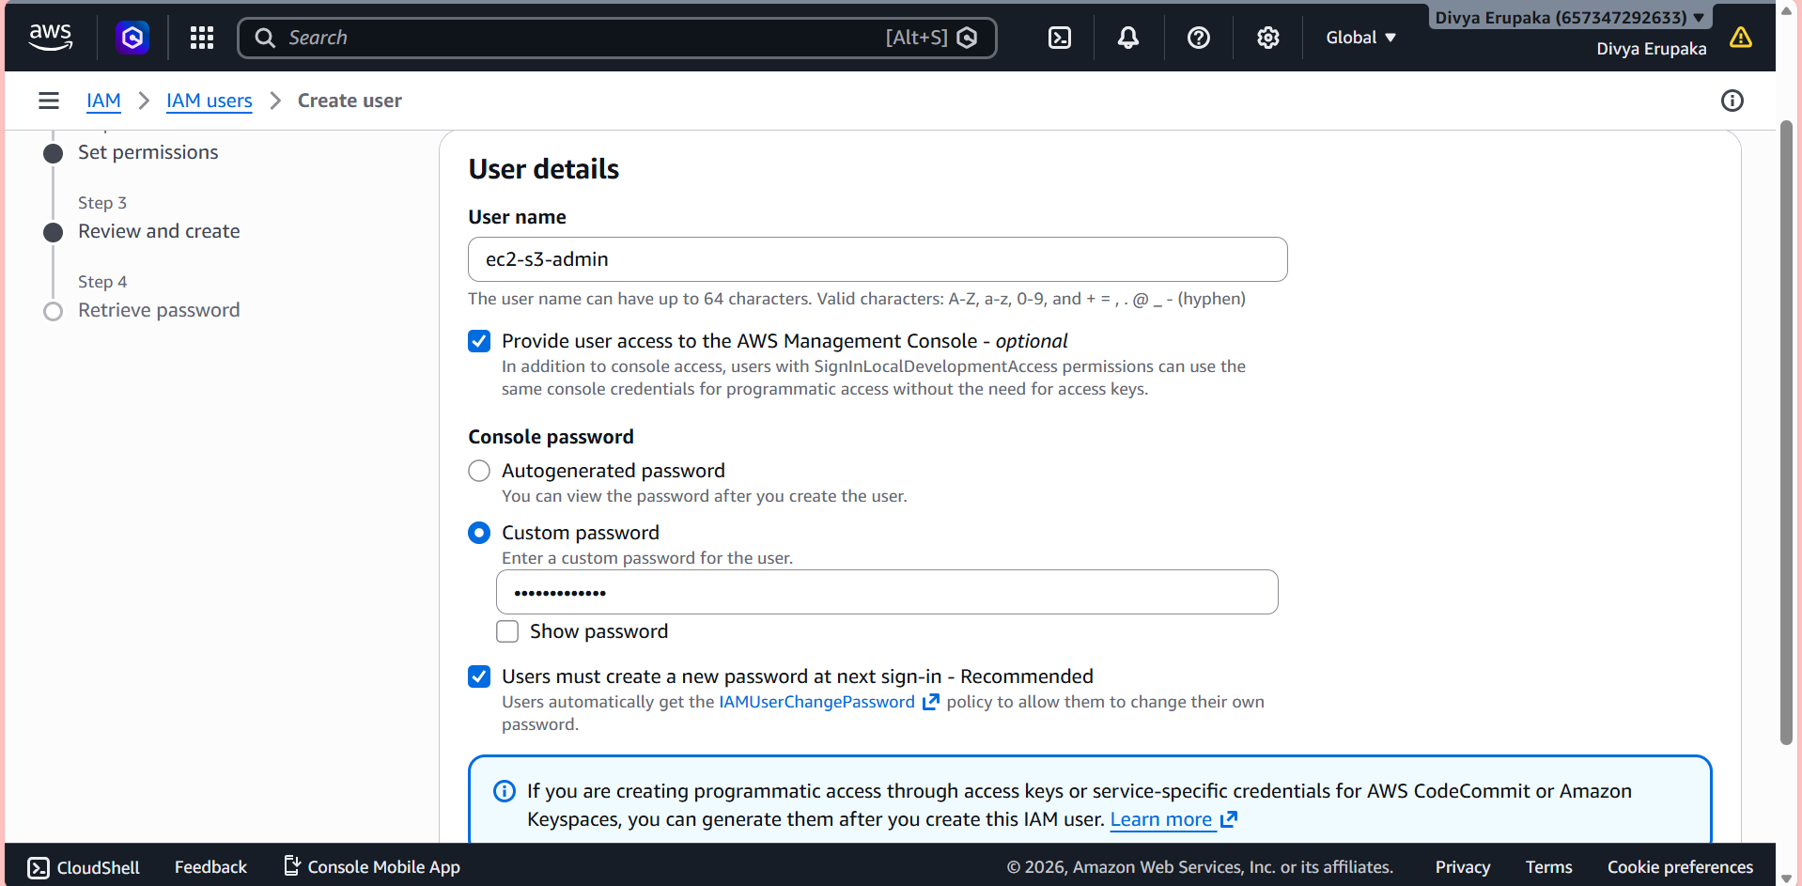
Step 4: Assign Permissions
Choose:
Attach policies directly
Search and attach the following AWS-managed policies:
Policy 1
AmazonEC2FullAccess
Policy 2
AmazonS3FullAccess
Both policies should be selected.
Click Next.
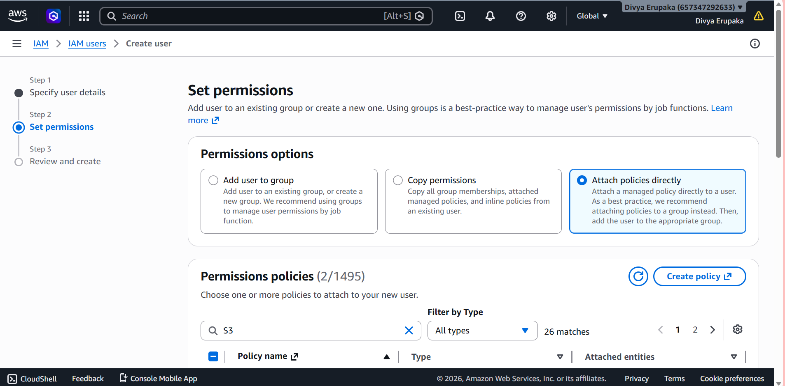
Step 5: Review and Create User
Review the configuration:
Username: ec2-s3-admin
Console Access: Enabled
Permissions:
- AmazonEC2FullAccess
- AmazonS3FullAccess
Click Create User.
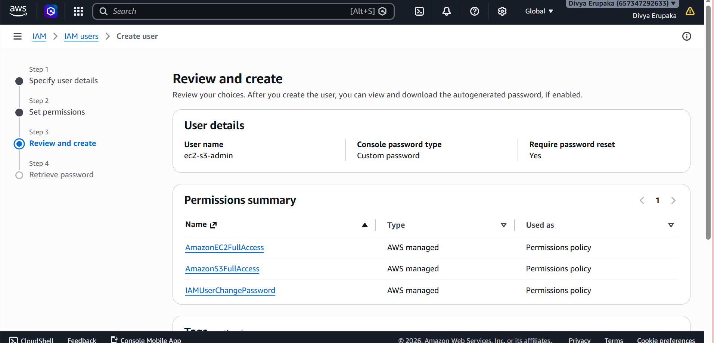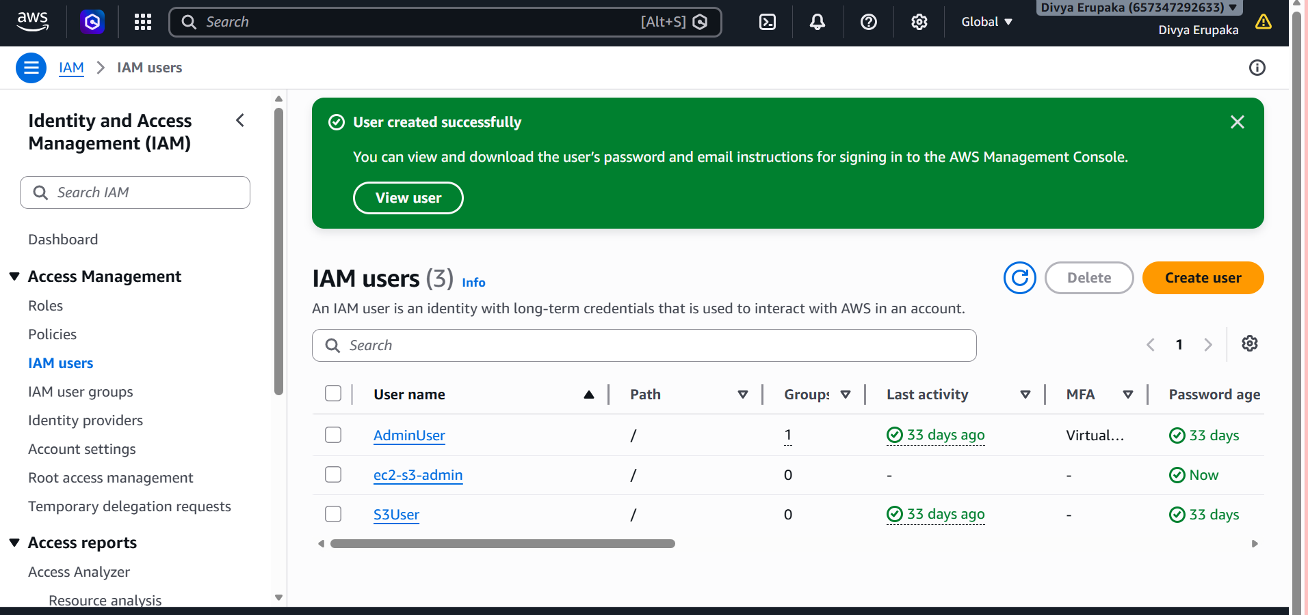
Step 6: Save Login Information
After user creation, AWS displays:
Console Sign-In URL
Username
Password
Save these details securely for future login.
Example:
https://<account-id>.signin.aws.amazon.com/console
Username: ec2-s3-admin
Password: ********
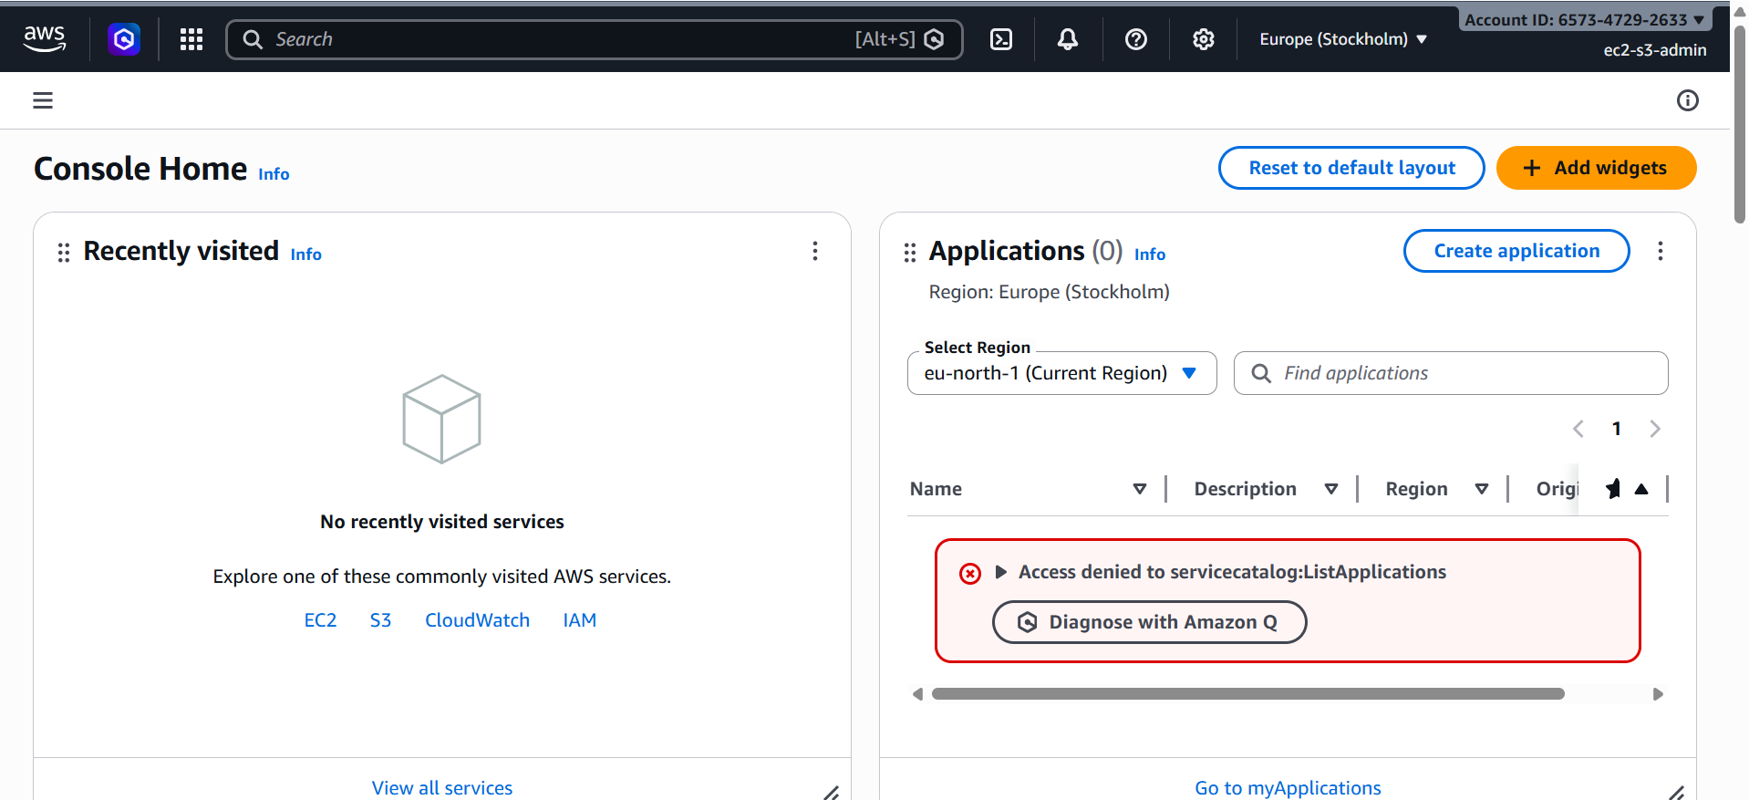
Verification
Verify IAM User Creation
Navigate to:
IAM → Users
Confirm that the user appears in the users list.

Verify Attached Permissions
Open the created user and select:
Permissions
Verify the following policies are attached:
AmazonEC2FullAccess
AmazonS3FullAccess

Verify Console Login
- Open the AWS Sign-In URL.
- Log in using:
  - Username
  - Password
Successful login confirms console access is configured correctly.

Verify EC2 Access
After logging in as the IAM user:
Navigate to:
AWS Console → EC2
Verify that the user can:
- View instances
- Launch instances
- Stop instances
- Terminate instances
This confirms EC2 full access.
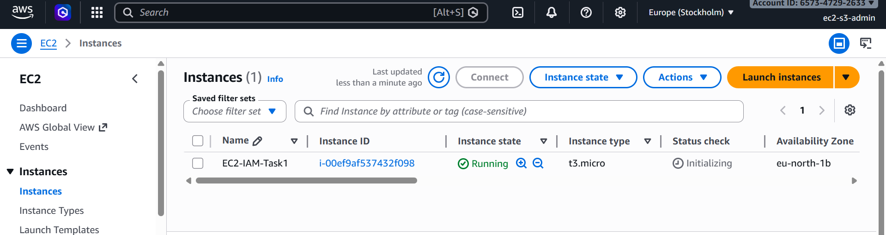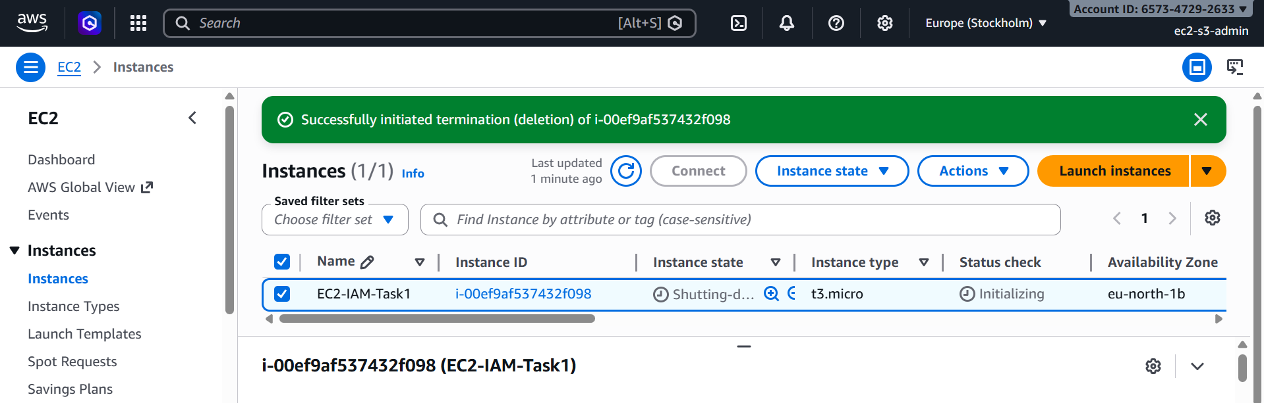
Verify S3 Access
Navigate to:
AWS Console → S3
Verify that the user can:
- Create buckets
- Upload files
- Download files
- Delete objects
This confirms S3 full access.
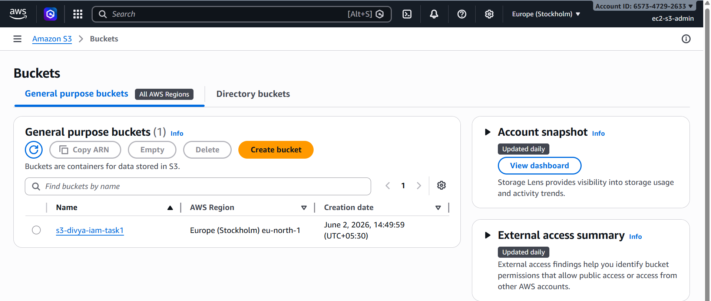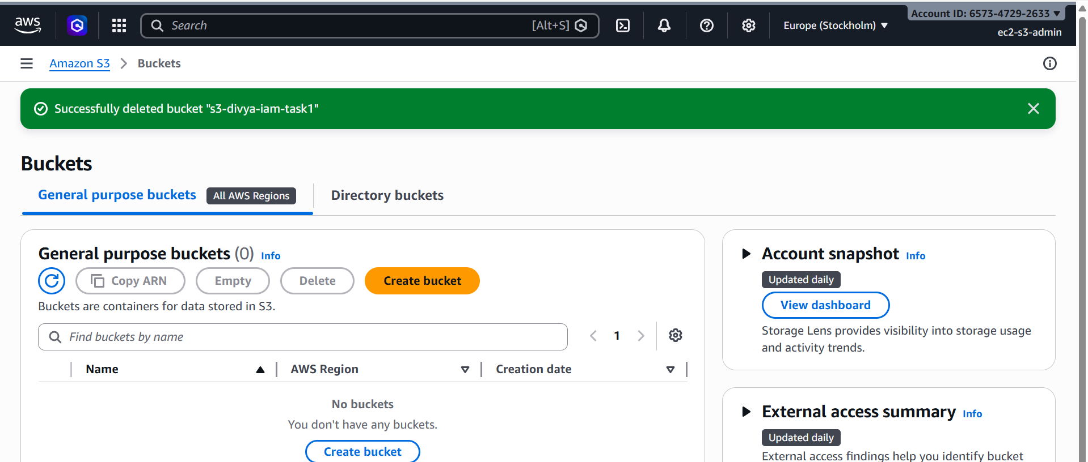

Result
Successfully created an IAM user with AWS Management Console access and assigned the following AWS-managed policies:
- AmazonEC2FullAccess
- AmazonS3FullAccess
The user can now log in to the AWS Management Console and perform all EC2 and S3 administrative operations.
Task 2: Create an IAM Group and Assign Read-Only Access to EC2
Objective
Create an IAM group in AWS and assign read-only permissions for Amazon EC2. Users added to this group will be able to view EC2 resources but will not be able to create, modify, start, stop, or terminate instances.

Prerequisites
- AWS Account with IAM administrative permissions.
- Access to the AWS Management Console.

Step 1: Open IAM Console
- Log in to the AWS Management Console.
- Search for IAM in the AWS search bar.
- Open the IAM Dashboard.
- From the left navigation pane, select User Groups.
- Click Create Group.

Step 2: Create IAM Group
Group Details
Enter the group name:
EC2-ReadOnly-Group
Click Next.
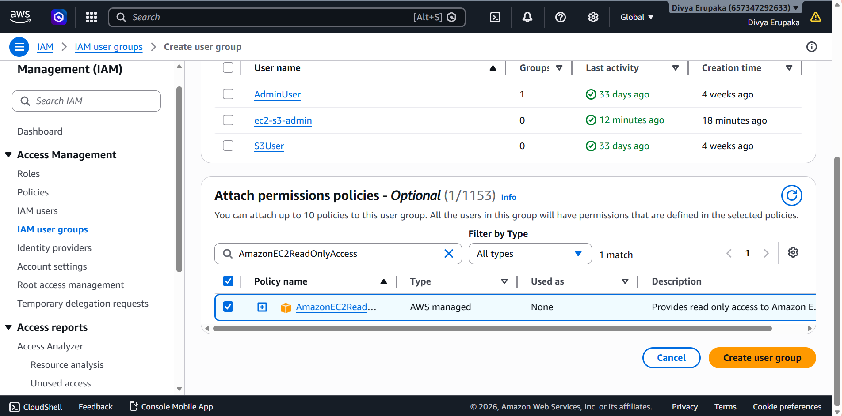

Step 3: Assign EC2 Read-Only Permission
Under Permissions Policies, search for:
AmazonEC2ReadOnlyAccess
Select the policy:
AmazonEC2ReadOnlyAccess
This AWS-managed policy allows users to:
- View EC2 Instances
- View Security Groups
- View VPCs
- View AMIs
- View Volumes
- View Snapshots
- View Load Balancers
Users cannot:
- Launch Instances
- Stop/Start Instances
- Reboot Instances
- Modify Security Groups
- Delete Resources
Click Next.
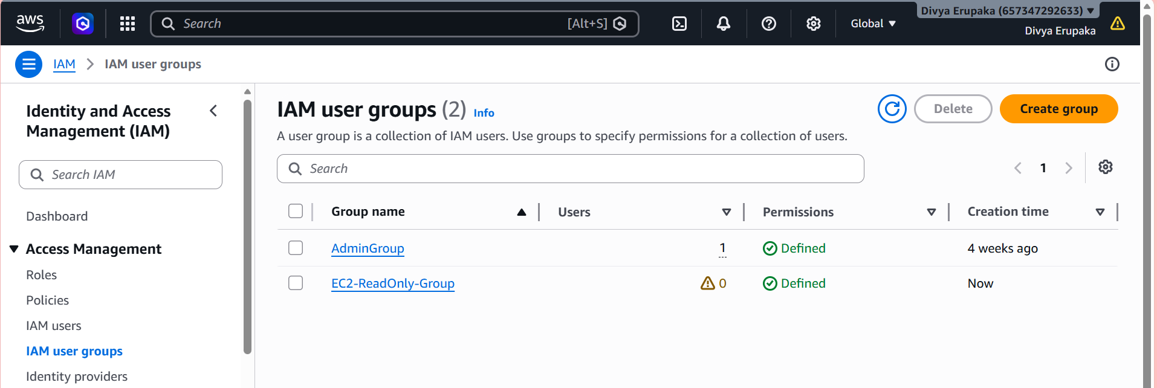
Step 4: Review and Create Group
Verify the configuration:
Group Name: EC2-ReadOnly-Group
Attached Policy:
AmazonEC2ReadOnlyAccess
Click Create Group.
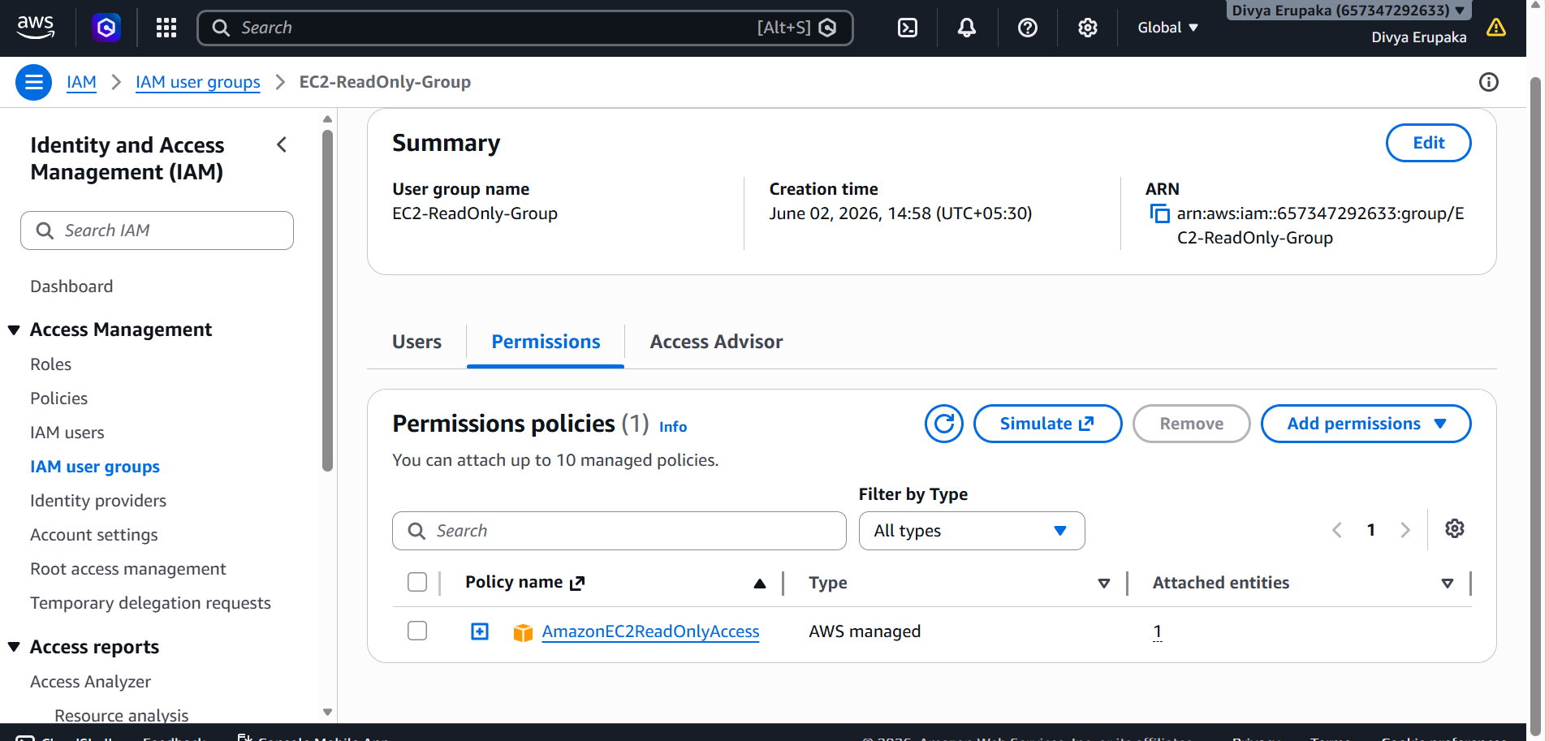
Step 5: Add User to the Group
- Open the newly created group.
- Click Add Users.
- Select the desired IAM user(s).
Example:
ec2-s3-admin
- Click Add Users.
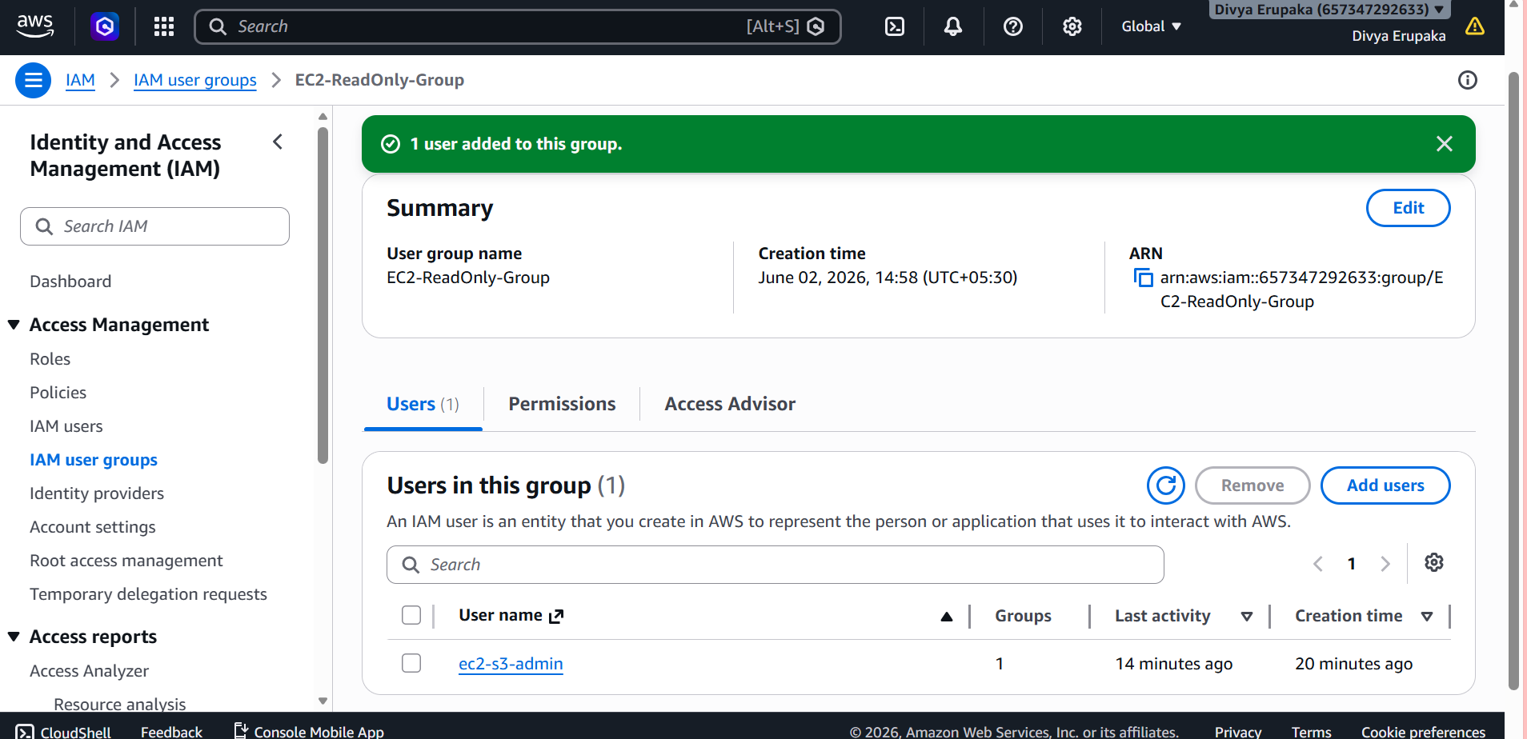
Verification
Verify Group Creation
Navigate to:
IAM → User Groups
Confirm that the group exists:
EC2-ReadOnly-Group
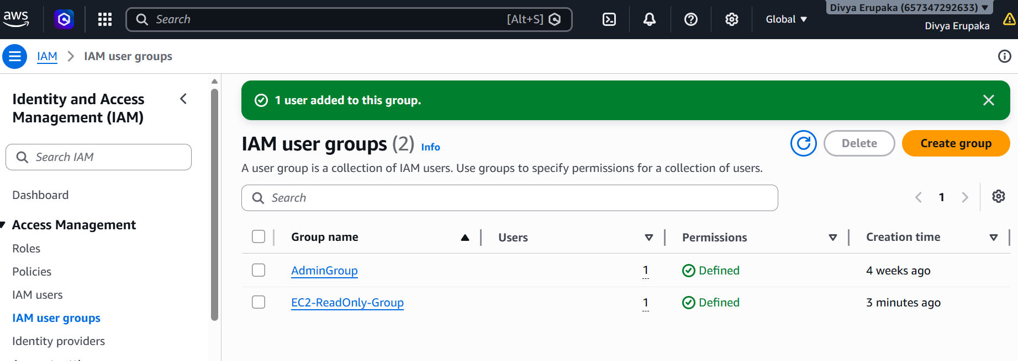
Verify Attached Policy
Open the group and select:
Permissions
Verify the attached policy:
AmazonEC2ReadOnlyAccess
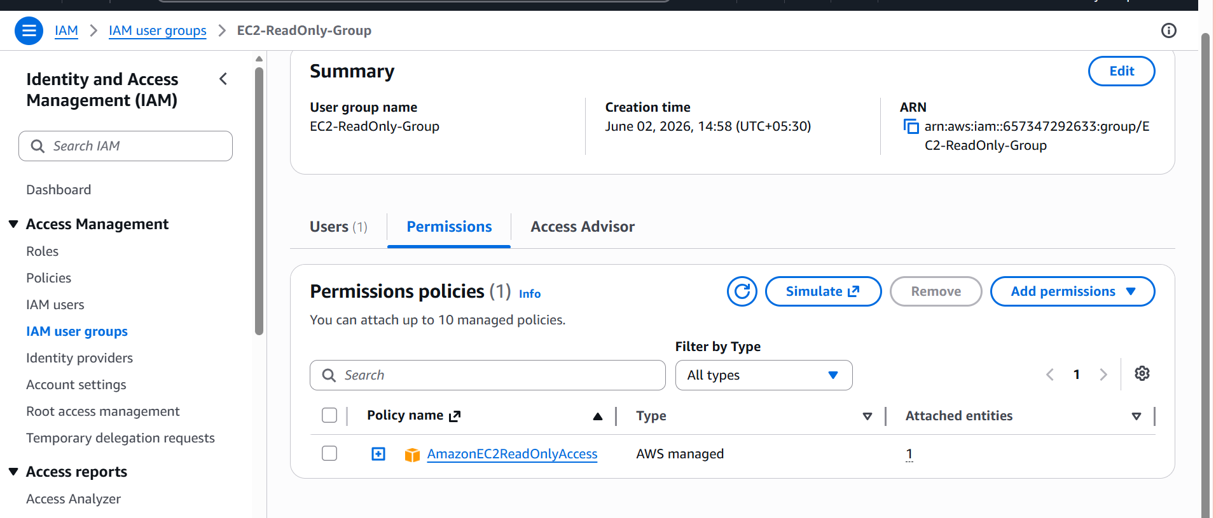
Verify User Membership
Open:
IAM → User Groups → EC2-ReadOnly-Group → Users
Confirm the intended user is listed.
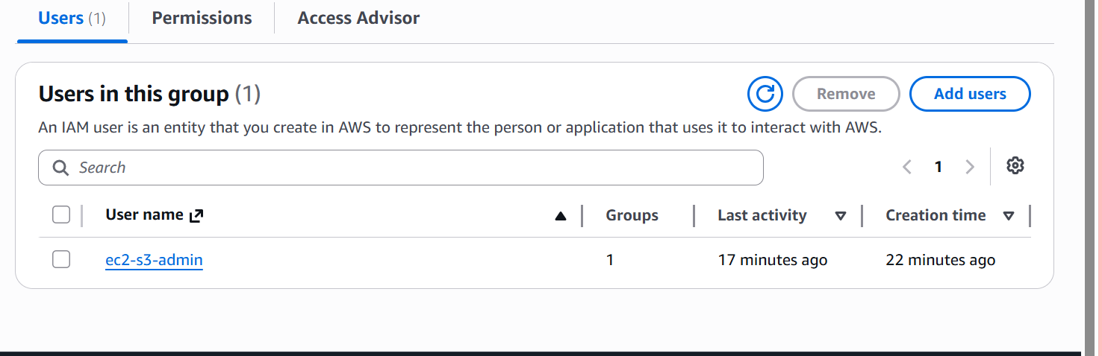
Verify EC2 Read-Only Access
Log in using a user that only has permissions through this group.
Navigate to:
AWS Console → EC2
Verify the user can:
✅ View EC2 instances
✅ View Security Groups
✅ View Volumes
✅ View Snapshots
✅ View VPCs
Attempt to perform any of the following:
❌ Launch Instance
❌ Stop Instance
❌ Terminate Instance
❌ Modify Security Group
AWS should display an Access Denied message.
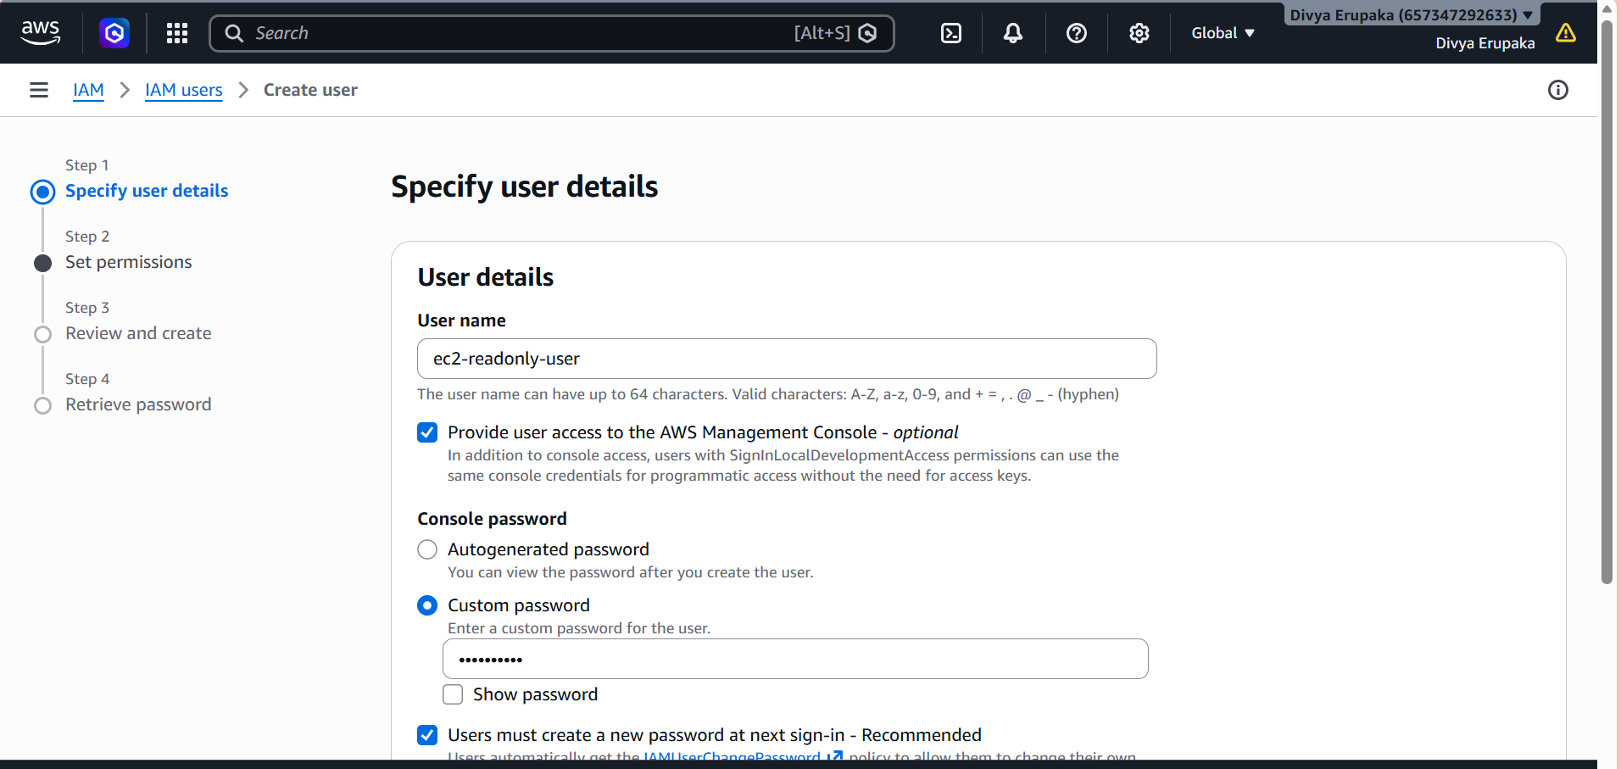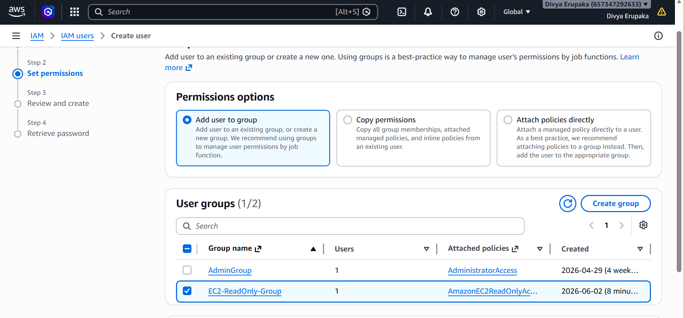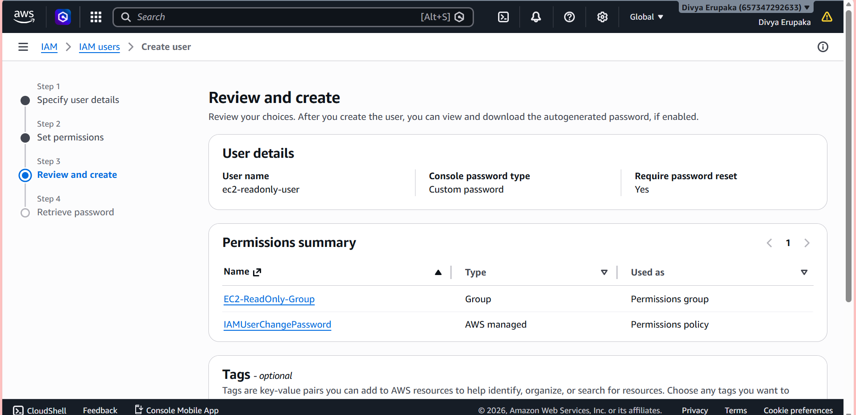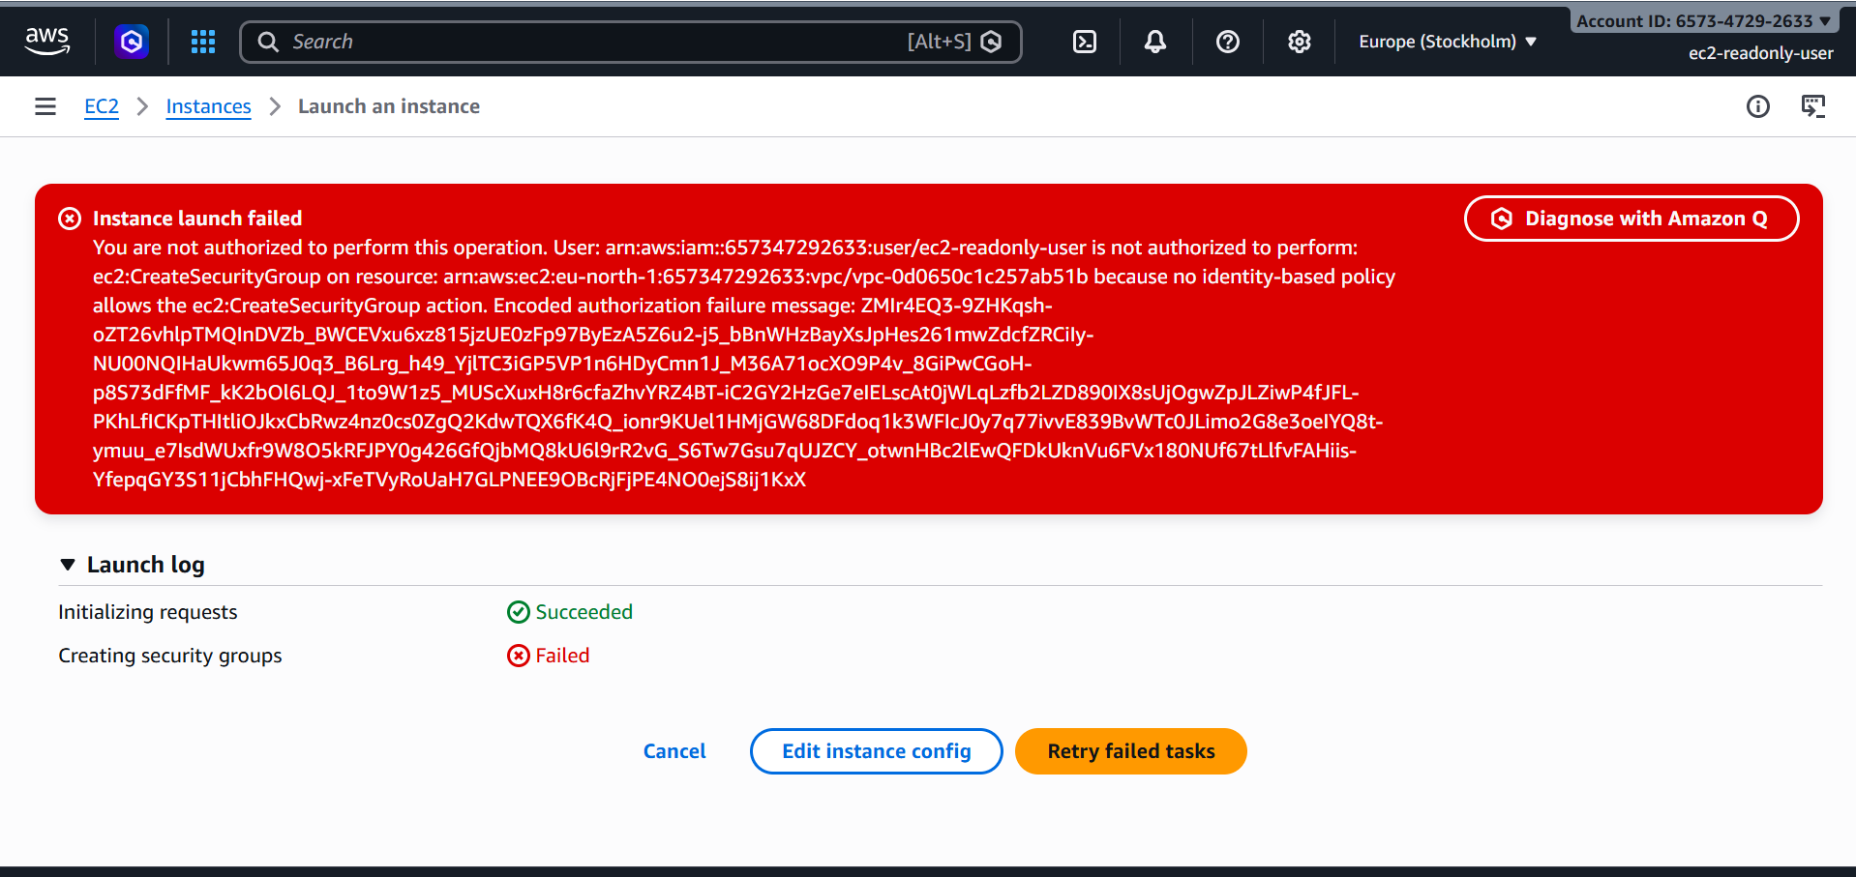
Result
Successfully created an IAM group named EC2-ReadOnly-Group and attached the AmazonEC2ReadOnlyAccess policy. Users added to this group can view EC2 resources while being restricted from performing any administrative or modification actions.
Task 3: Create a New IAM User "Devops" and Add to EC2 Read-Only Group
Objective
Create a new IAM user named Devops and add the user to the existing IAM group EC2-ReadOnly-Group created in Task 2. The user will inherit the group's EC2 read-only permissions.

Prerequisites
- AWS Account with IAM administrative permissions.
- Existing IAM Group:
EC2-ReadOnly-Group
- The group should already have the policy:
AmazonEC2ReadOnlyAccess

Step 1: Open IAM Console
- Log in to the AWS Management Console.
- Navigate to IAM.
- Select Users from the left navigation pane.
- Click Create User.

Step 2: Create the User
Enter the following details:
User Name: Devops
Enable AWS Management Console access:
Provide user access to the AWS Management Console
Choose:
I want to create an IAM user
Set a password:
Custom Password
Enter a secure password and click Next.
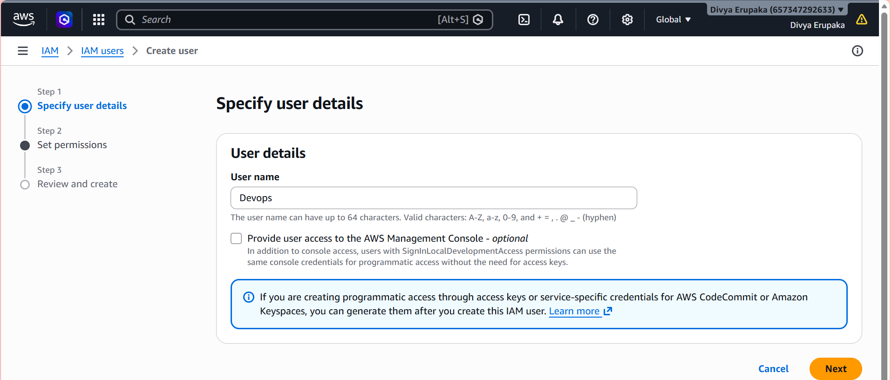
Step 3: Add User to Existing Group
Under Set Permissions, select:
Add user to group
Choose the existing group:
EC2-ReadOnly-Group
The user will automatically inherit:
AmazonEC2ReadOnlyAccess
Click Next.
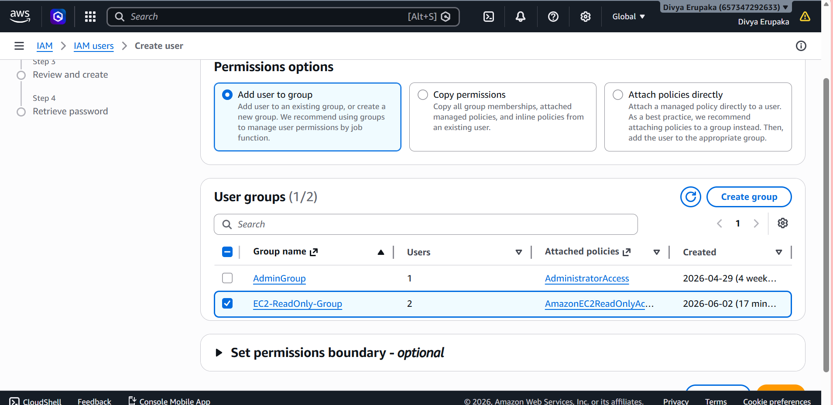
Step 4: Review and Create User
Verify:
User Name: Devops
Group:
EC2-ReadOnly-Group
Inherited Policy:
AmazonEC2ReadOnlyAccess
Click:
Create User
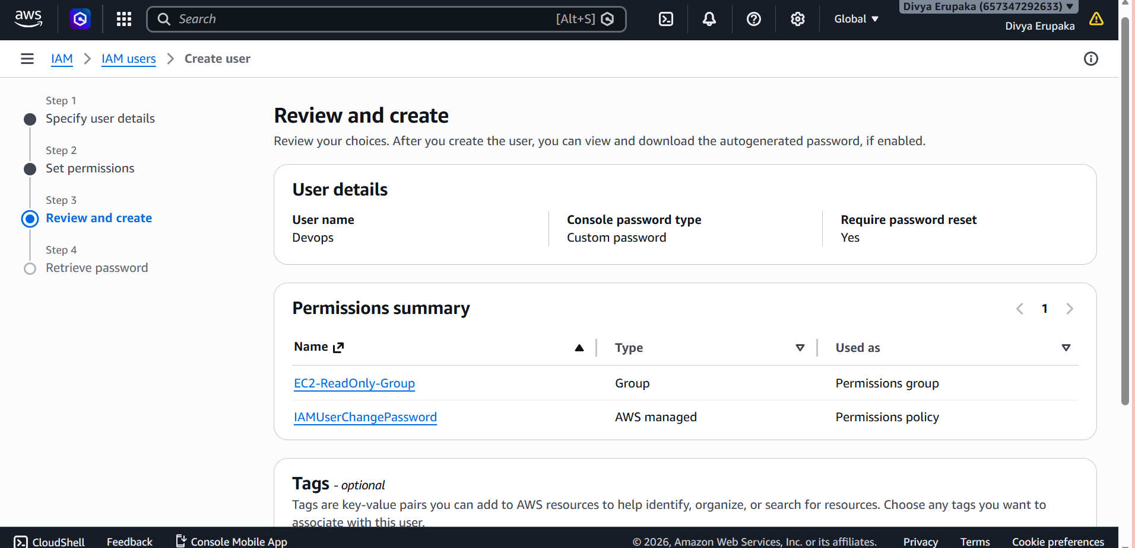
Step 5: Save Login Details
After creation, note the following:
AWS Console Sign-In URL
Username: Devops
Password: ********
Store these credentials securely.
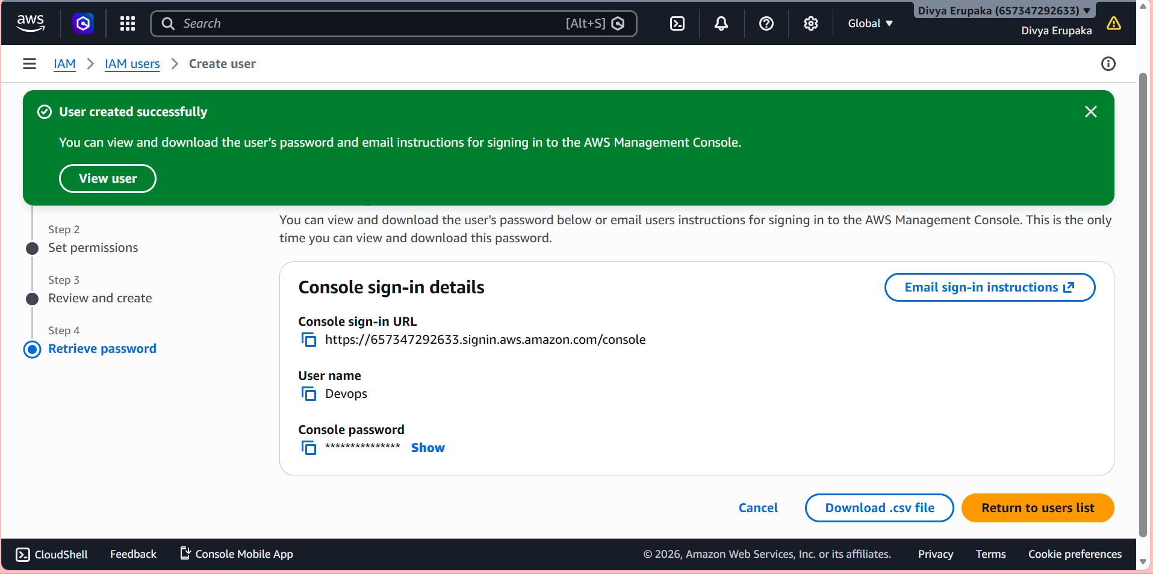
Verification
Verify User Creation
Navigate to:
IAM → Users
Confirm the user exists:
Devops

Verify Group Membership
Navigate to:
IAM → User Groups → EC2-ReadOnly-Group → Users
Verify that:
Devops
appears in the group members list.

Verify Inherited Permissions
Open:
IAM → Users → Devops → Permissions
You should see:
Permissions inherited from group:
EC2-ReadOnly-Group
Policy attached through the group:
AmazonEC2ReadOnlyAccess

Test EC2 Access
Log in as:
Devops
Navigate to:
EC2 Console
Verify:
✅ Can view EC2 instances
✅ Can view Security Groups
✅ Can view Volumes
✅ Can view VPCs
Attempt to launch an instance:
❌ Access Denied
Attempt to stop an instance:
❌ Access Denied
This confirms that the user has inherited read-only permissions from the group.
Result
Successfully created the IAM user Devops and added it to the EC2-ReadOnly-Group. The user inherited the AmazonEC2ReadOnlyAccess policy from the group and can view EC2 resources while being restricted from creating, modifying, or deleting EC2 resources.

Task 4: Write a Bash Script to Create an IAM User with VPC Full Access
Objective
Create a Bash script that automatically:
- Creates an IAM user.
- Attaches the AWS managed policy AmazonVPCFullAccess.
- Verifies the user creation and policy attachment.
This automation helps administrators quickly provision IAM users with full access to Amazon VPC resources.

Prerequisites
Before executing the script, ensure:
- AWS CLI is installed.
- AWS CLI is configured with administrative credentials.
- The IAM user running the script has permission to:
  - Create IAM users
  - Attach IAM policies
Verify AWS CLI installation:
aws --version
Expected Output:
aws-cli/2.x.x
Verify AWS Configuration:
aws sts get-caller-identity

Step 1: Create the Bash Script
Create a new file:
vi create-vpc-user.sh
Paste the following code:
#!/bin/bash
# User Name
USER_NAME="vpc-admin"
echo "Creating IAM User: $USER_NAME"
# Create IAM User
aws iam create-user \
--user-name $USER_NAME
# Attach Amazon VPC Full Access Policy
aws iam attach-user-policy \
--user-name $USER_NAME \
--policy-arn arn:aws:iam::aws:policy/AmazonVPCFullAccess
echo "-----------------------------------"
echo "IAM User Created Successfully"
echo "Policy Attached: AmazonVPCFullAccess"
echo "User Name: $USER_NAME"
echo "-----------------------------------"
Save and exit:
Press ESC
:wq
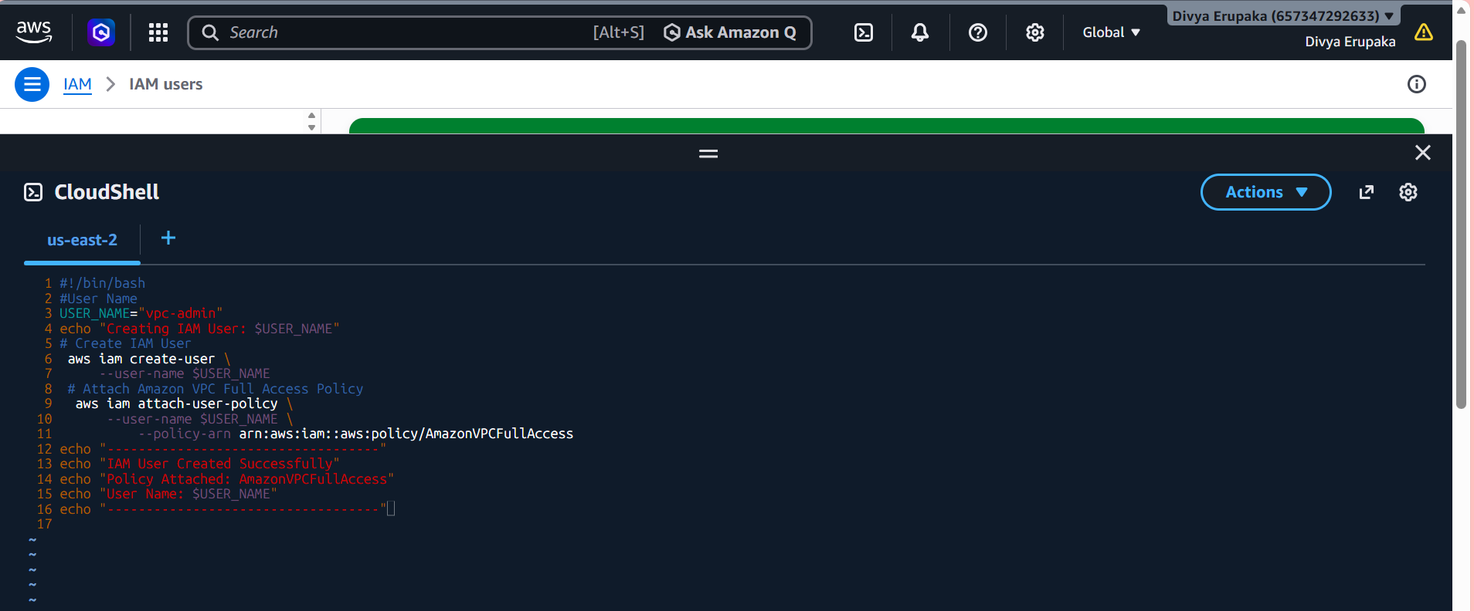
Step 2: Make the Script Executable
Provide execute permissions:
chmod +x create-vpc-user.sh
Verify permissions:
ls -ltr create-vpc-user.sh
Expected Output:
-rwxr-xr-x

Step 3: Execute the Script
Run the script:
./create-vpc-user.sh
Expected Output:
Creating IAM User: vpc-admin
-----------------------------------
IAM User Created Successfully
Policy Attached: AmazonVPCFullAccess
User Name: vpc-admin
-----------------------------------
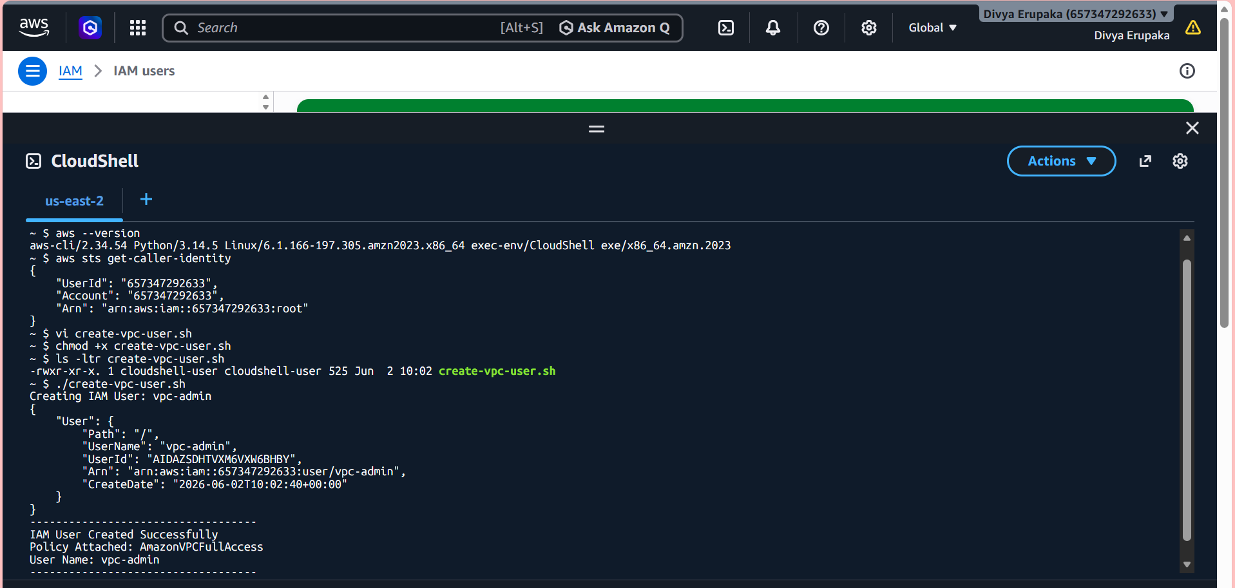
Step 4: Verify IAM User Creation
Check whether the user exists:
aws iam get-user \
--user-name vpc-admin
Expected Output:
{
"User": {
"UserName": "vpc-admin",
"Arn": "arn:aws:iam::123456789012:user/vpc-admin"
}
}
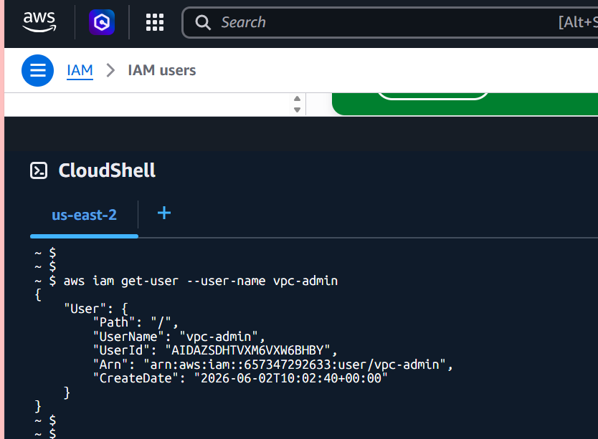
Step 5: Verify Attached Policy
List attached policies:
aws iam list-attached-user-policies \
--user-name vpc-admin
Expected Output:
{
"AttachedPolicies": [
{
"PolicyName": "AmazonVPCFullAccess"
}
]
}
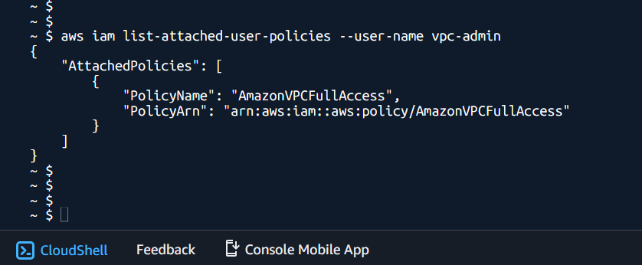
Step 6: Verify from AWS Console
Navigate to:
AWS Console
→ IAM
→ Users
→ vpc-admin
Open:
Permissions
Verify the attached policy:
AmazonVPCFullAccess
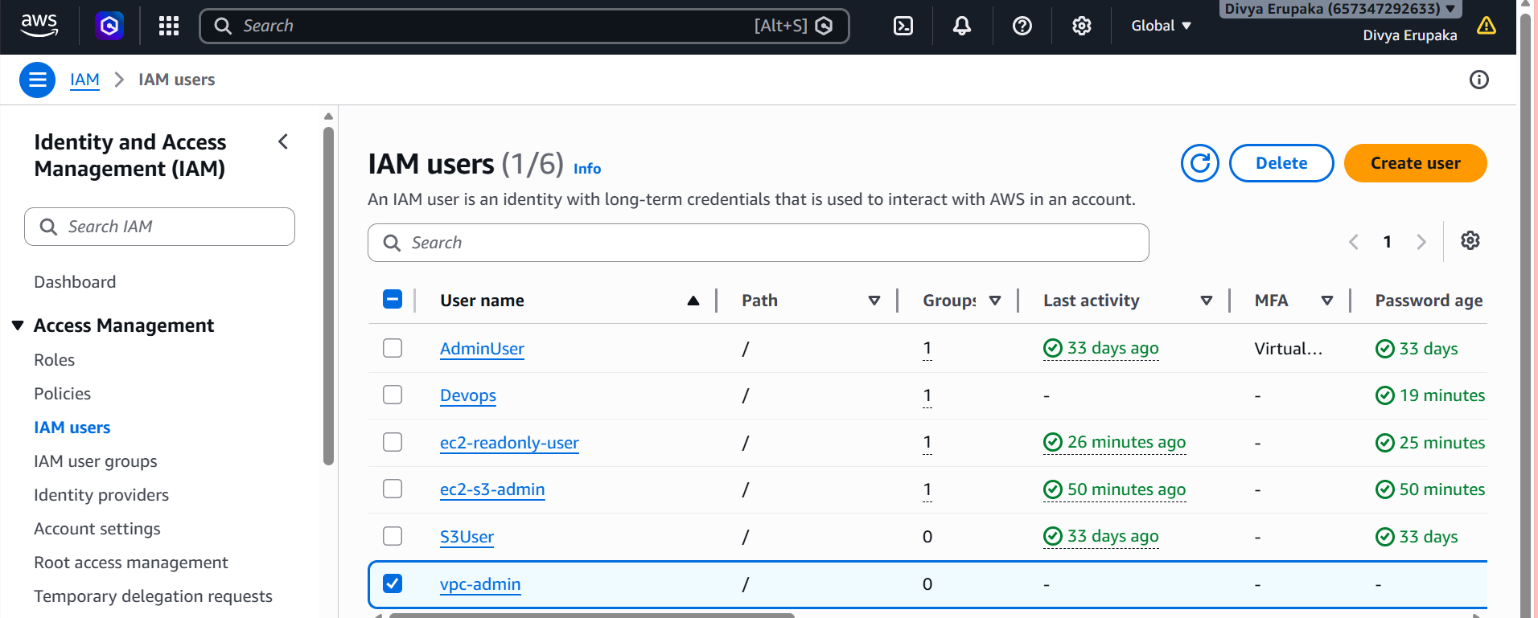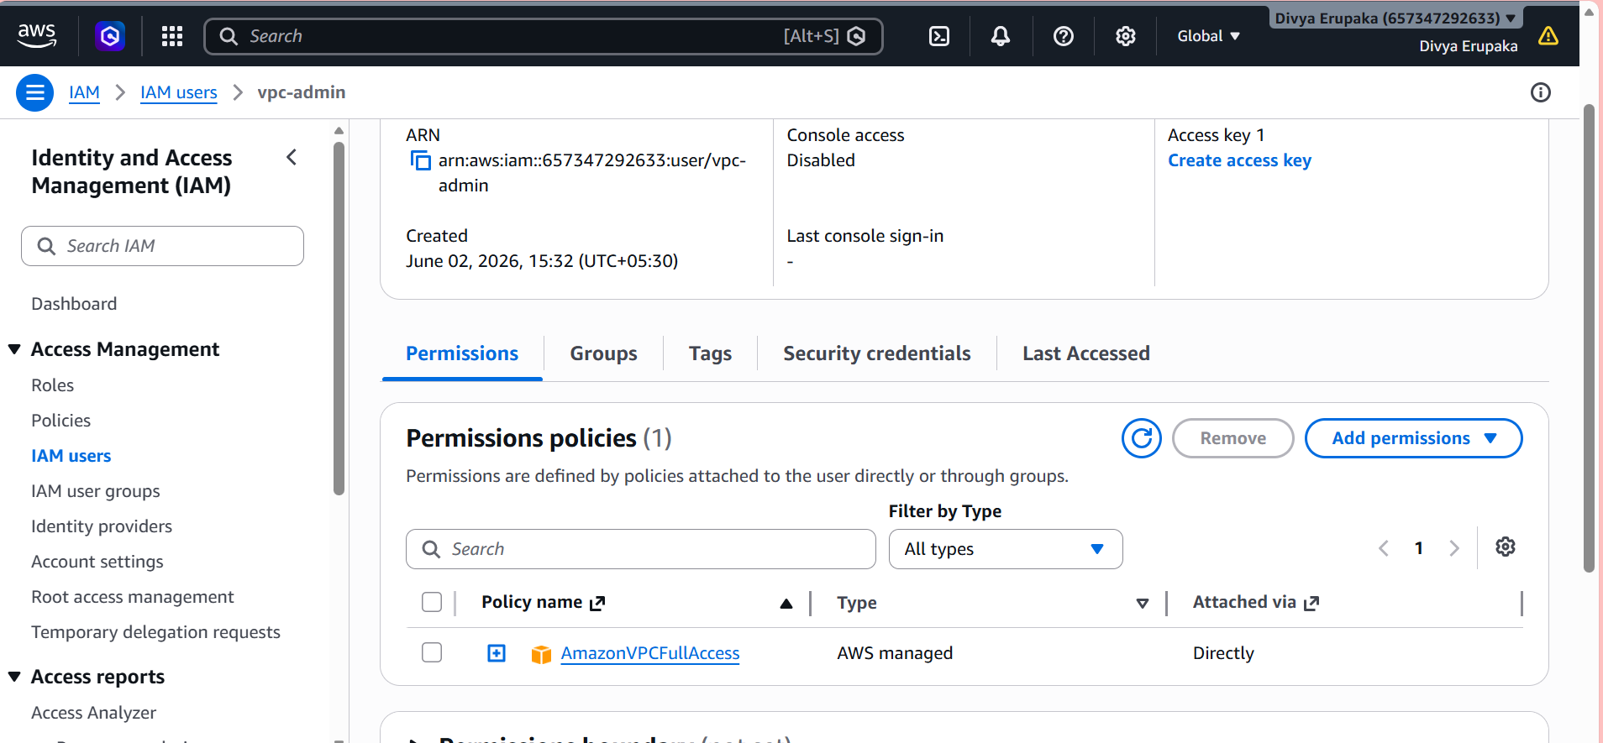
Understanding the Policy
The AWS Managed Policy:
AmazonVPCFullAccess
Provides permissions to manage:
- VPCs
- Subnets
- Route Tables
- Internet Gateways
- NAT Gateways
- Security Groups
- Network ACLs
- Elastic IPs
- VPC Peering Connections
- DHCP Option Sets
The user can create, modify, view, and delete VPC-related resources.
Result
Successfully created a Bash script that automates the creation of an IAM user named vpc-admin and assigns the AmazonVPCFullAccess AWS managed policy. The user now has full administrative access to Amazon VPC resources.
Task 5: Create an IAM Policy to Allow EC2 Access in Specific AWS Regions Only
Objective
Create a custom IAM policy that allows a user to perform EC2 actions only in specific AWS regions.
Example
Allow EC2 access only in:
- us-east-1 (N. Virginia)
- us-west-2 (Oregon)
Deny access to all other regions.

Step 1: Open IAM Console
- Log in to AWS Console.
- Navigate to IAM.
- Select Policies from the left menu.
- Click Create Policy.

Step 2: Choose JSON Editor
- Select the JSON tab.
- Remove the default content.
- Paste the following policy:
{
"Version": "2012-10-17",
"Statement": [
{
"Sid": "AllowEC2InSpecificRegions",
"Effect": "Allow",
"Action": "ec2:*",
"Resource": "*",
"Condition": {
"StringEquals": {
"aws:RequestedRegion": [
"us-east-1",
"us-west-2"
]
}
}
}
]
}
Click Next.
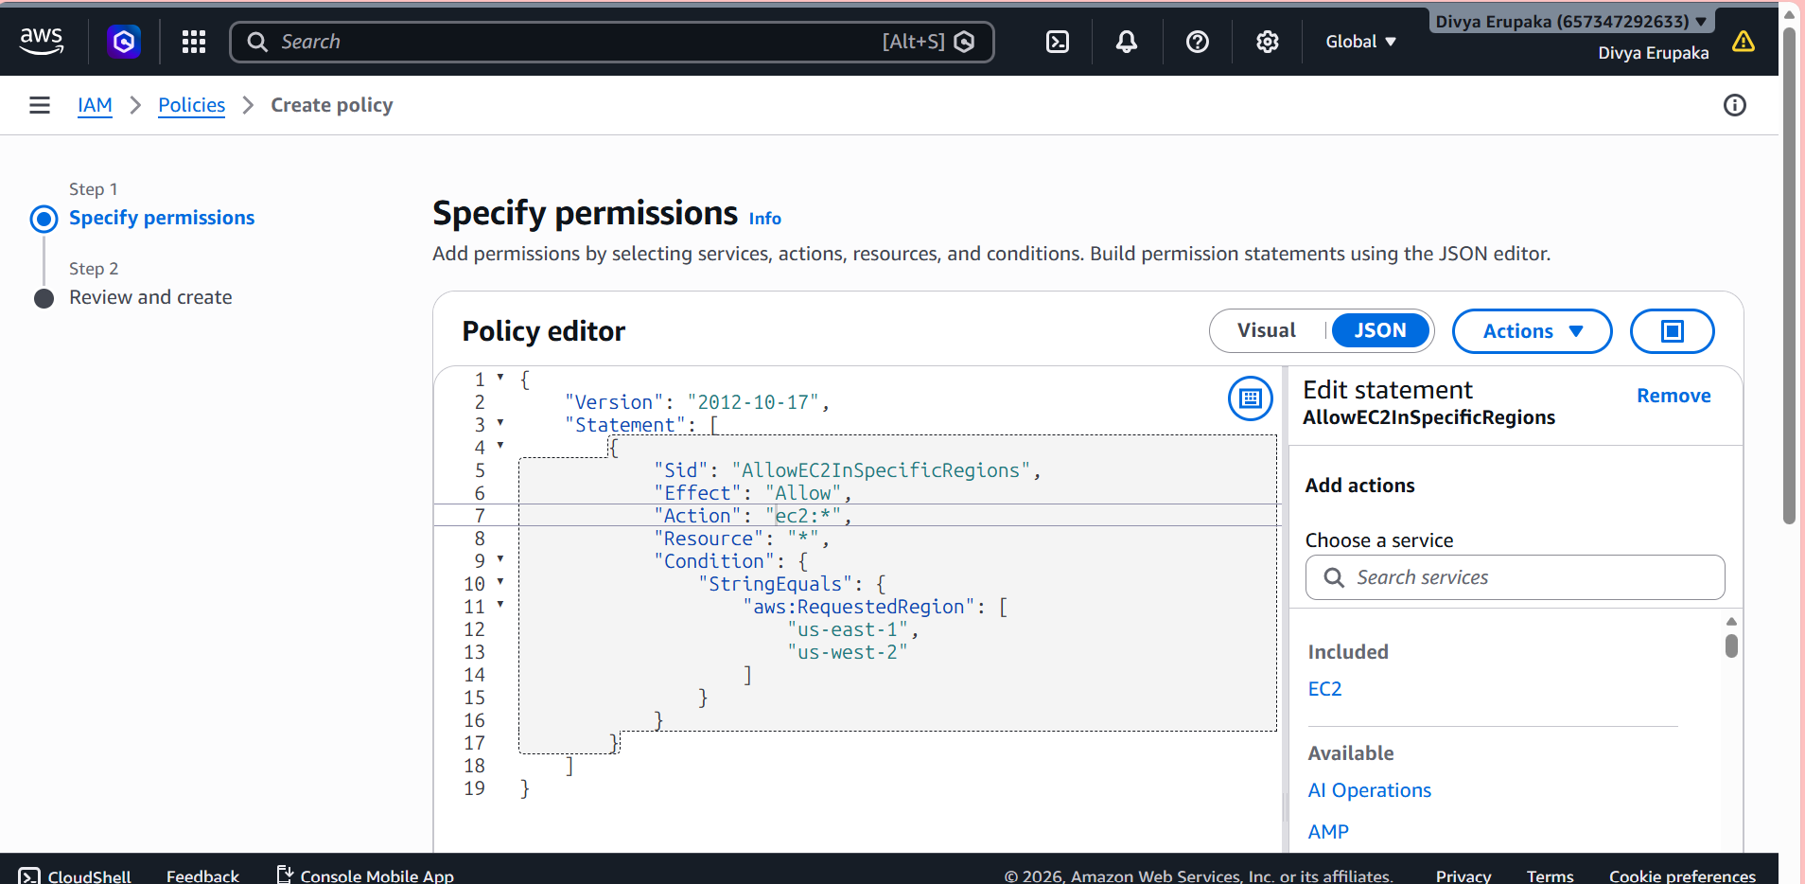
Step 3: Name the Policy
Enter:
EC2-Specific-Region-Access
Description:
Allows EC2 access only in us-east-1 and us-west-2 regions.
Click Create Policy.
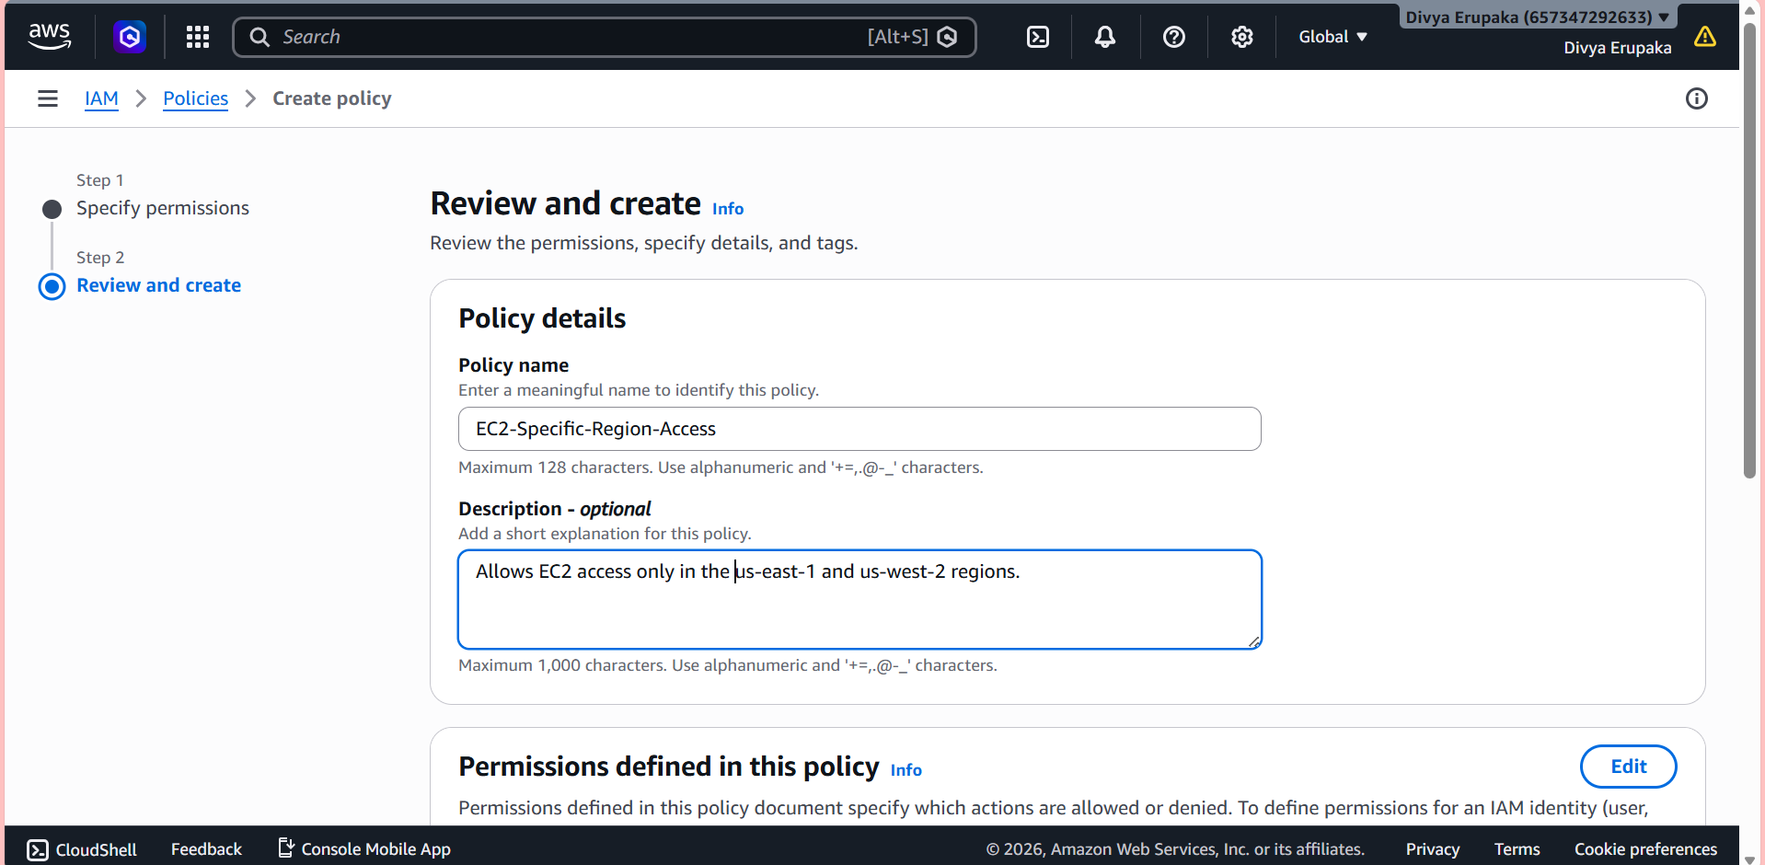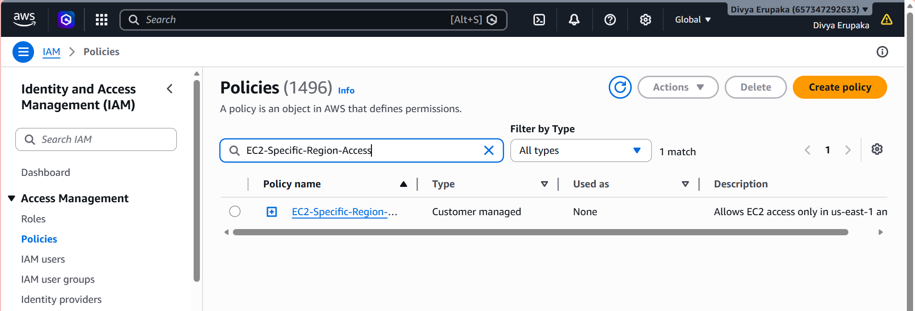
Step 4: Attach Policy to a User
- Navigate to:
IAM → Users
- Select the user.
Example:
Devops
- Open the Permissions tab.
- Click Add Permissions.
- Select:
Attach Policies Directly
- Search:
EC2-Specific-Region-Access
- Select the policy.
- Click Add Permissions.
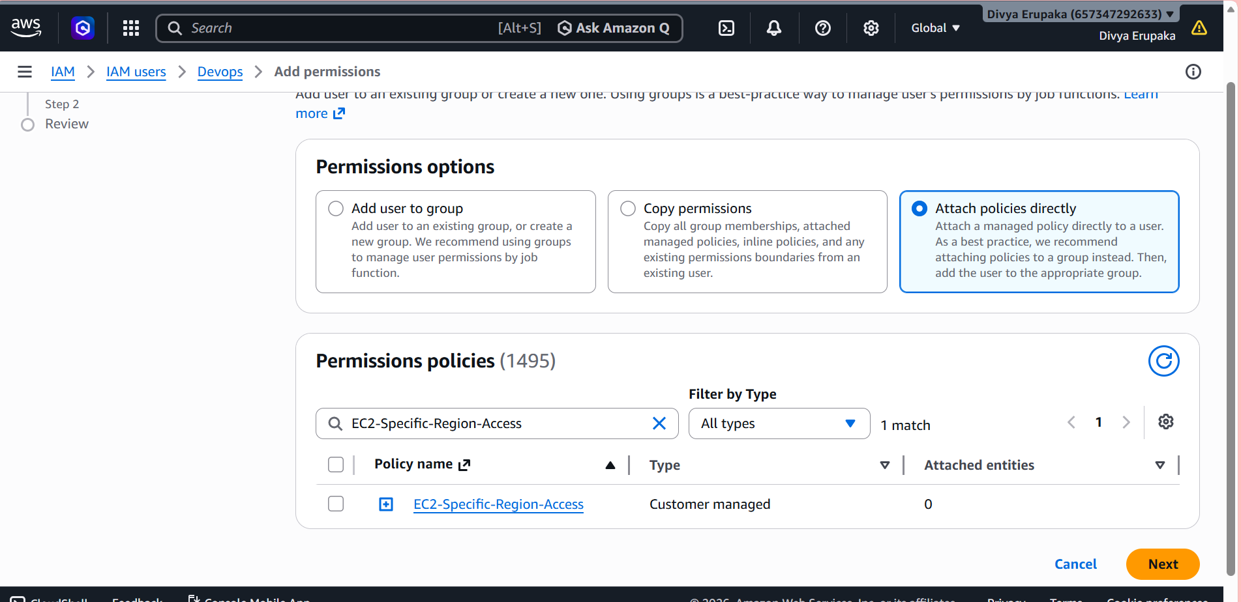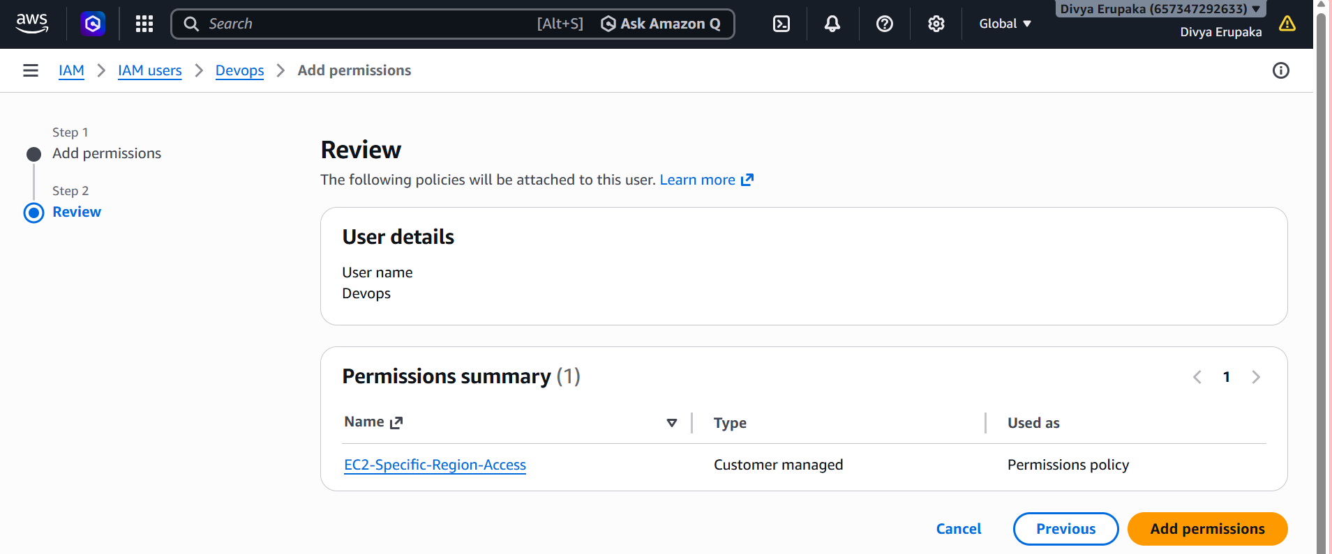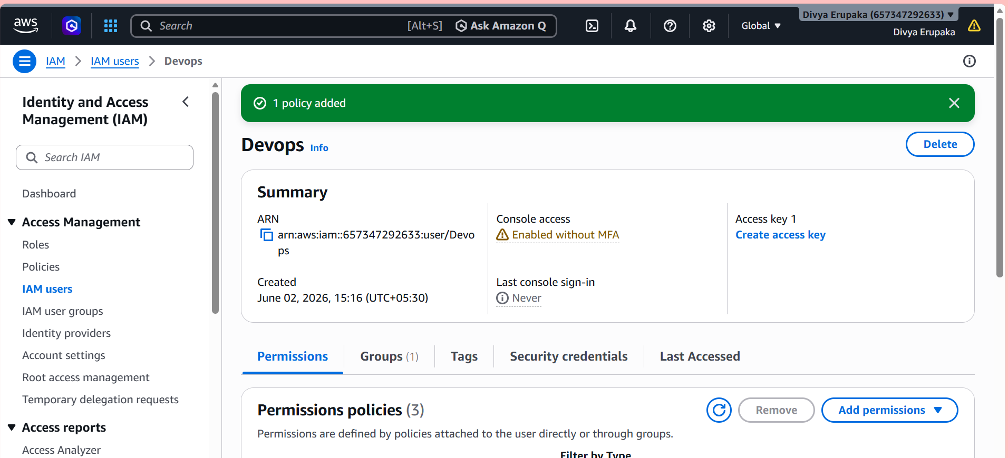
Step 5: Verification
Verify Access in Allowed Region
Switch AWS Region to:
us-east-1
Navigate to:
EC2 Console
Expected:
✅ User can view and manage EC2 resources.

Verify Access in Another Allowed Region
Switch to:
us-west-2
Expected:
✅ User can access EC2 resources.
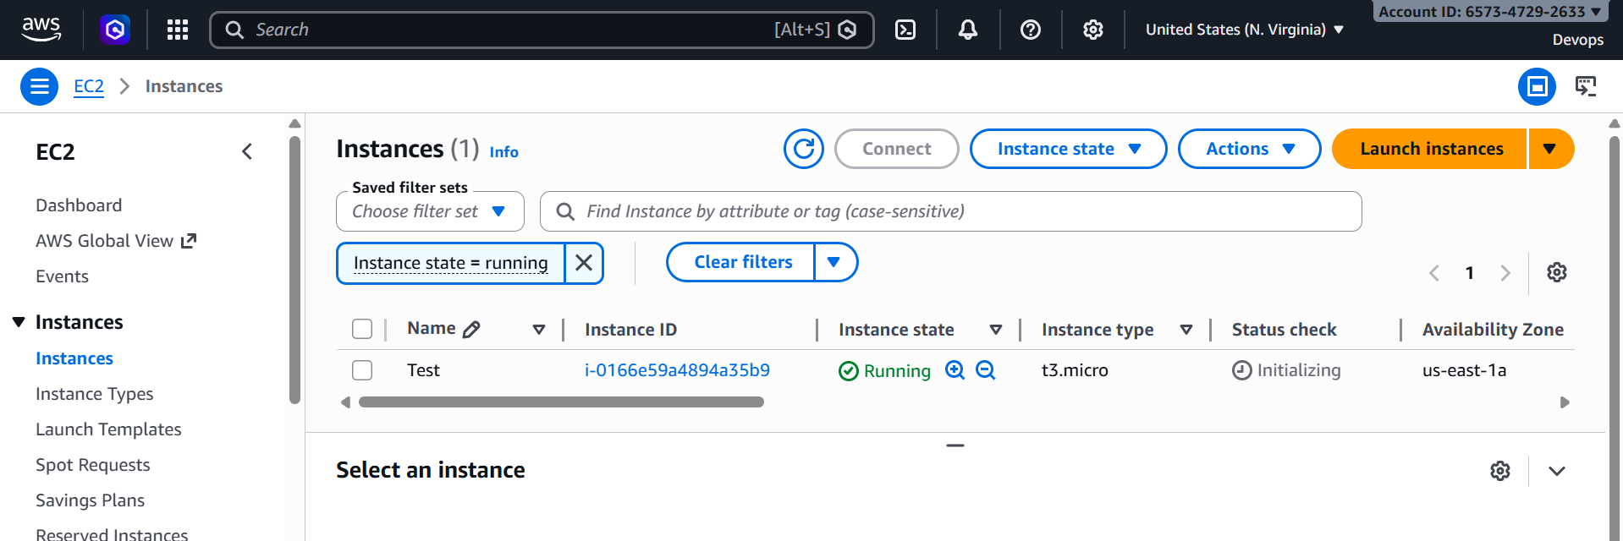
Verify Access in Restricted Region
Switch to:
ap-south-1 (Mumbai)
or
eu-west-1 (Ireland)
Expected:
❌ Access Denied
Example message:
You are not authorized to perform this operation.
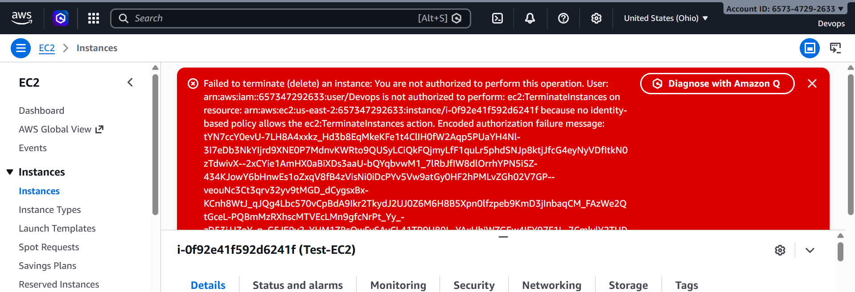
Result
Successfully created a custom IAM policy that restricts EC2 access to specific AWS regions only. The assigned user can manage EC2 resources in the approved regions while access to all other regions is denied.

Task 6: Configure Cross-Account S3 Access Between AWS Account A and Account B
Objective
The objective of this task is to allow an IAM user from AWS Account A to access an Amazon S3 bucket located in AWS Account B. This demonstrates Cross-Account Access using AWS IAM and S3 Bucket Policies, a common real-world and interview scenario.

Architecture
AWS Account A
-------------------------
IAM User: accountA-user
|
| Cross-Account Access
|
V
AWS Account B
-------------------------
S3 Bucket: accountb-shared-bucket

Prerequisites
- Access to two AWS accounts:
  - Account A (Source Account)
  - Account B (Target Account)
- IAM permissions to create users and manage S3 bucket policies.
- AWS Management Console access.

Step 1: Create an IAM User in Account A
- Log in to AWS Account A.
- Navigate to IAM Service.
- Select Users.
- Click Create User.
- Enter the username:
accountA-user
- Enable AWS Management Console access if required.
- Assign the following policy:
AmazonS3ReadOnlyAccess
- Complete the user creation process.
Verification
- Verify that the user is listed under IAM Users.
- Confirm that the AmazonS3ReadOnlyAccess policy is attached.
Evidence Required
- Screenshot of IAM User Creation.
- Screenshot showing attached permissions.
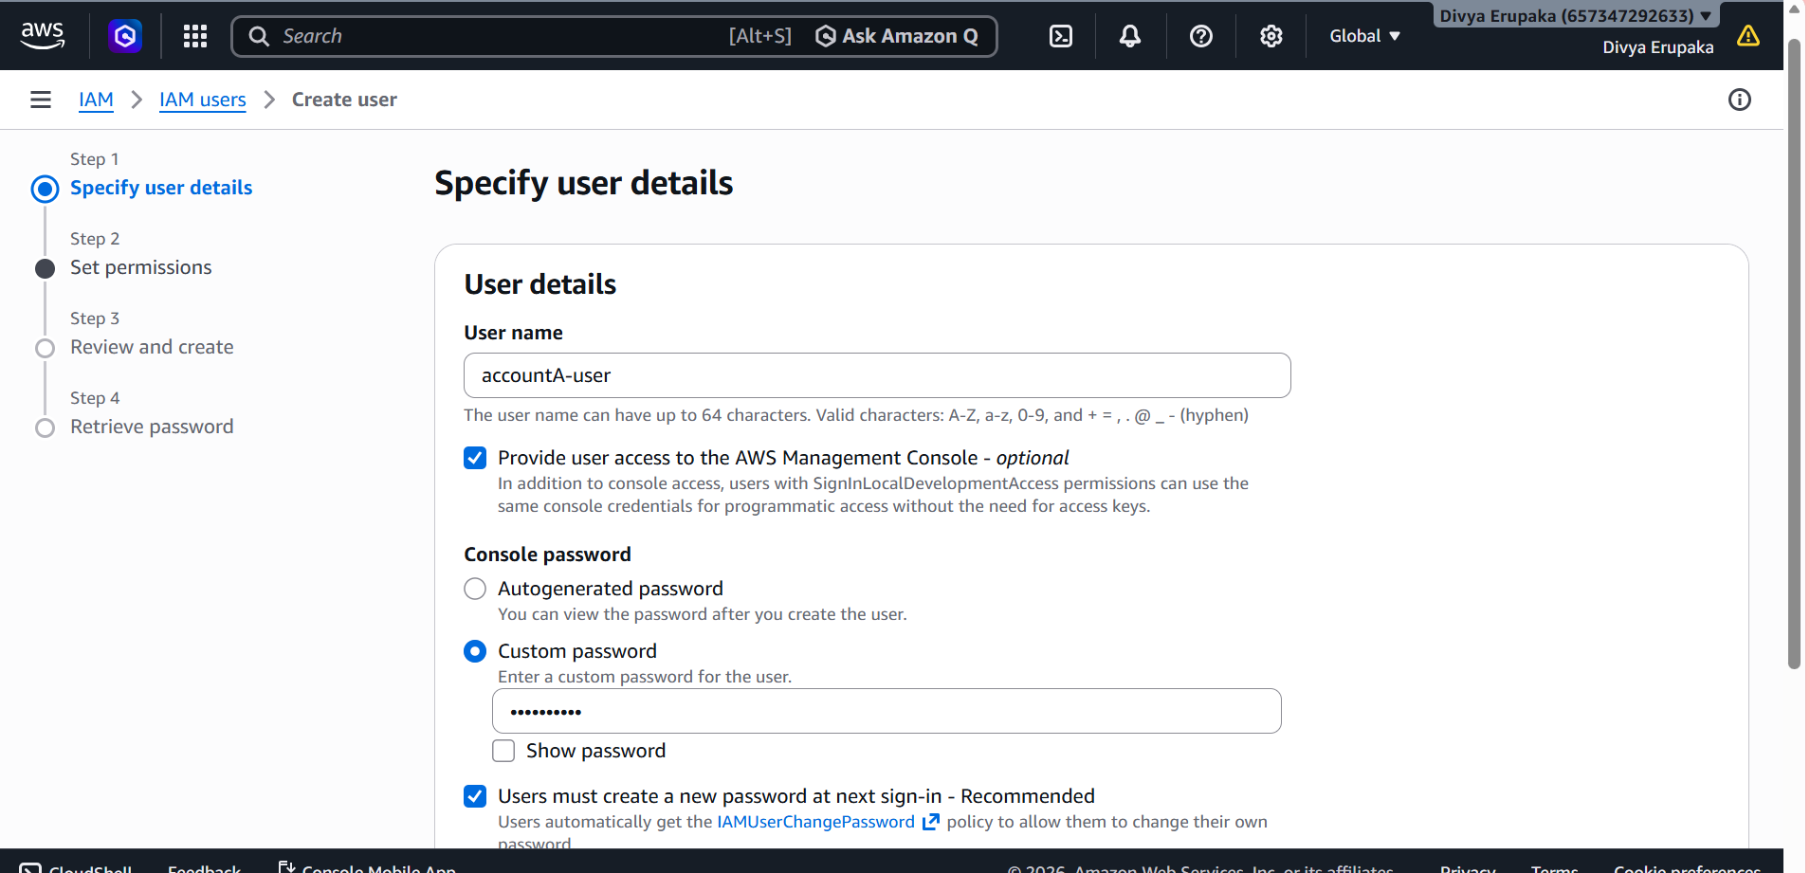
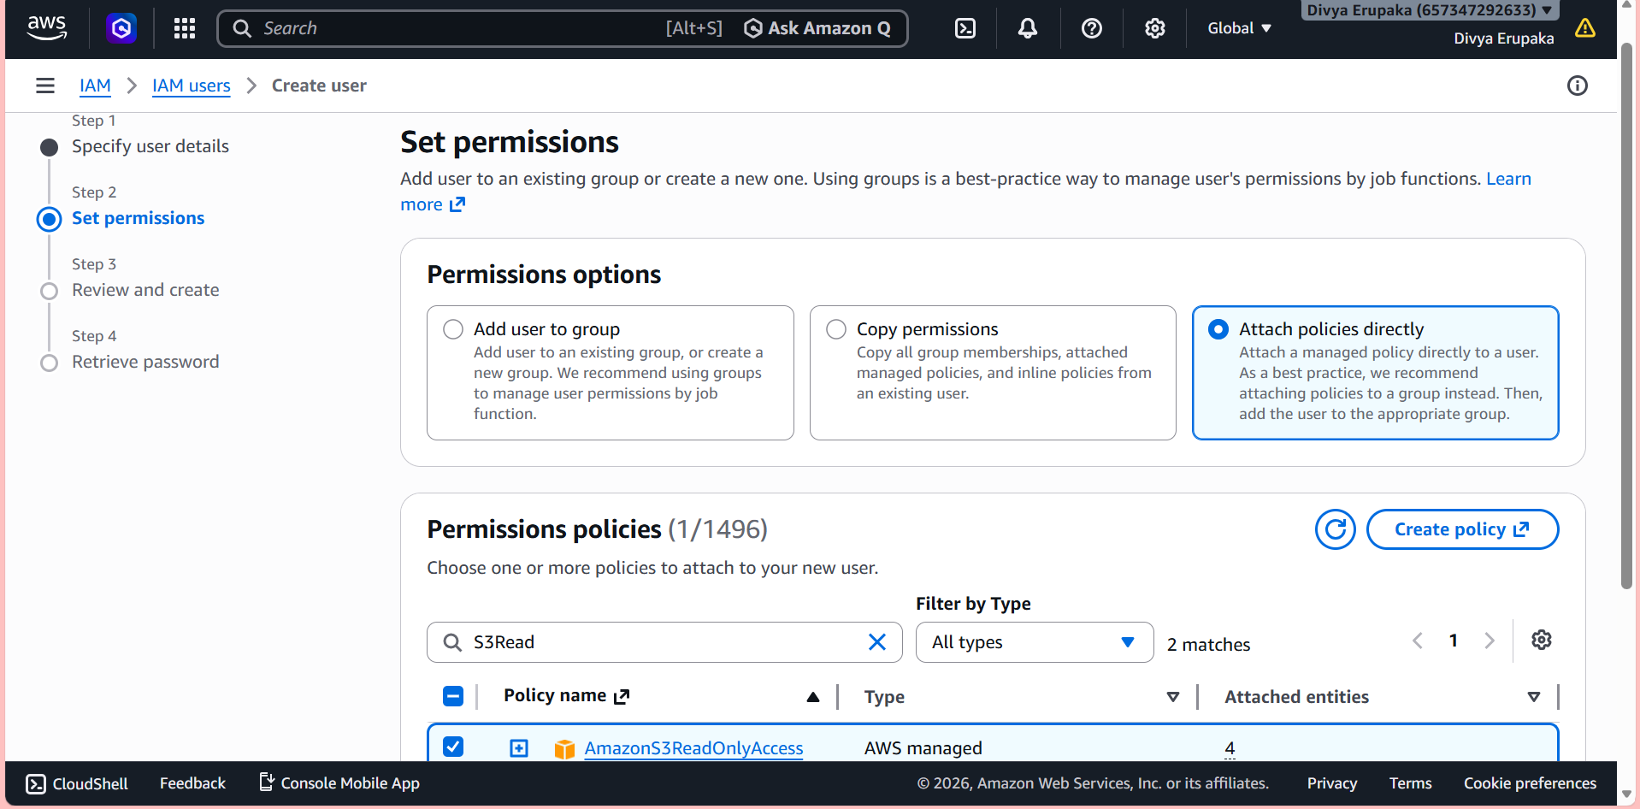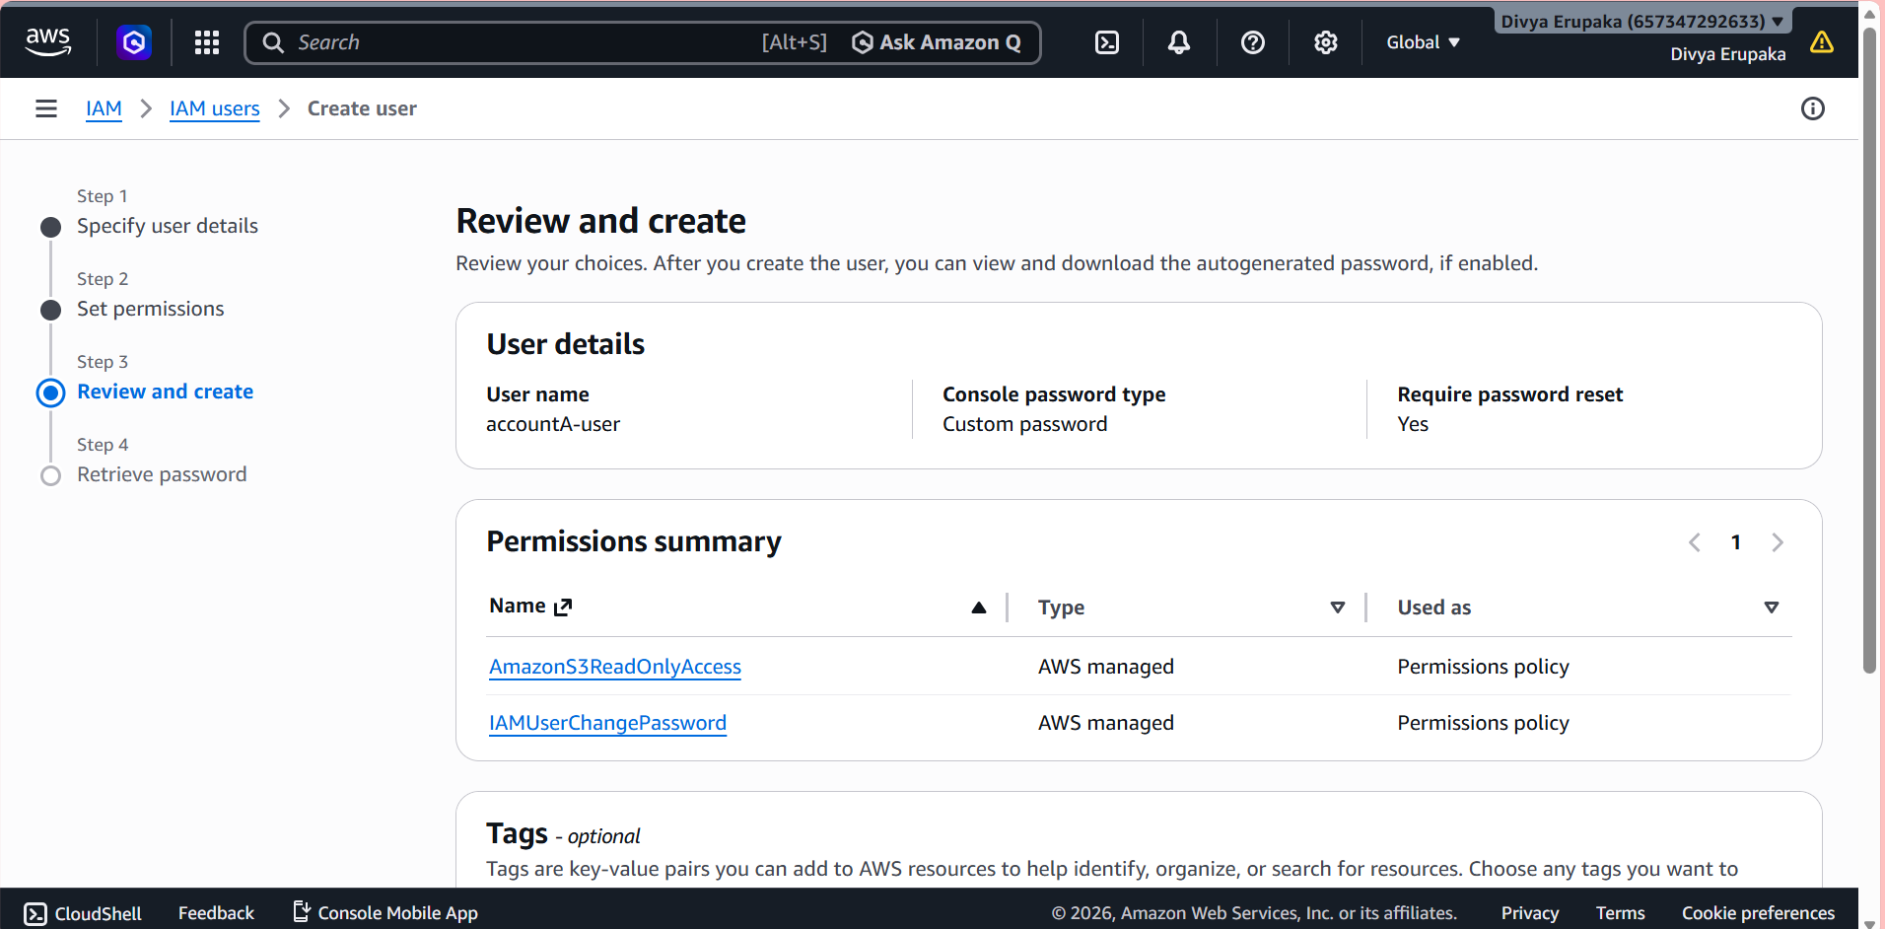

Step 2: Create an S3 Bucket in Account B
- Log in to AWS Account B.
- Navigate to Amazon S3.
- Click Create Bucket.
- Enter the bucket name:
accountb-shared-bucket
- Create the bucket.
- Upload a test file:
test.txt
Verification
- Confirm bucket creation.
- Verify that test.txt is uploaded successfully.
Evidence Required
- Screenshot of S3 Bucket.
- Screenshot showing uploaded file.

Step 4: Configure Bucket Policy in Account B
- Log in to AWS Account B.
- Navigate to:
S3 → accountb-shared-bucket → Permissions → Bucket Policy
- Add the following bucket policy:

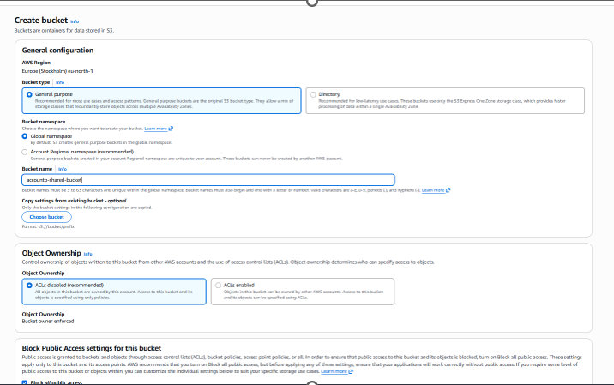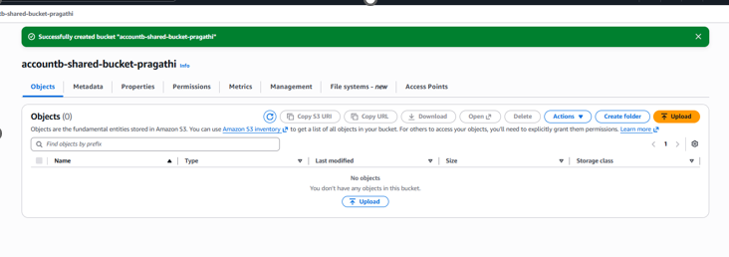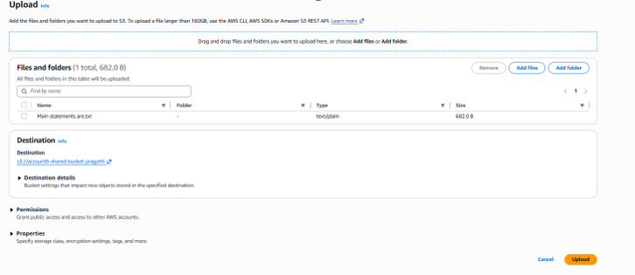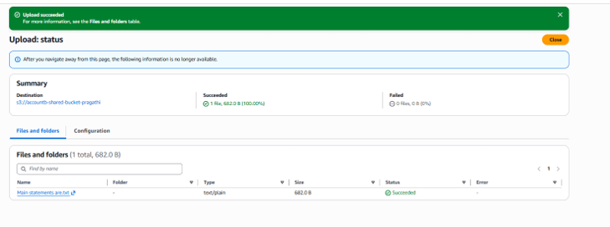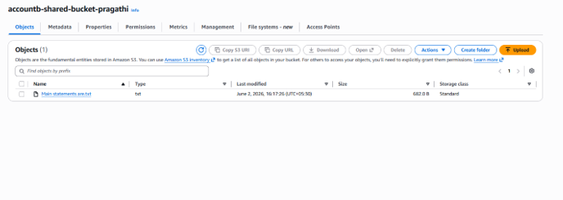
Step 3: Obtain Account A AWS Account ID
- Log in to Account A.
- Click on the account name in the top-right corner.
- Copy the AWS Account ID.
Alternatively, execute:
aws sts get-caller-identity
Evidence Required
- Screenshot showing AWS Account ID.
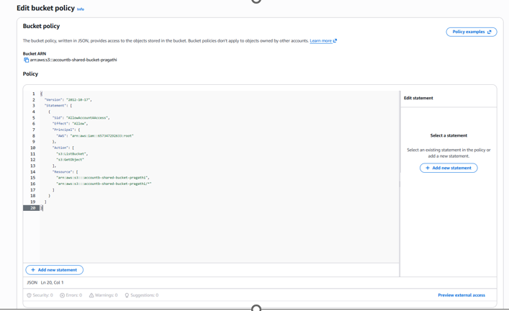
Step 5: Verify Access from Account A
Method 1: AWS Management Console
- Log in using accountA-user.
- Navigate to Amazon S3.
- Open the bucket:
accountb-shared-bucket
Expected Result
- Bucket is visible.
- Objects are visible.
- test.txt is accessible.
- File download is successful.
Evidence Required
- Screenshot showing bucket access.
- Screenshot showing object visibility.
- Screenshot showing successful download.
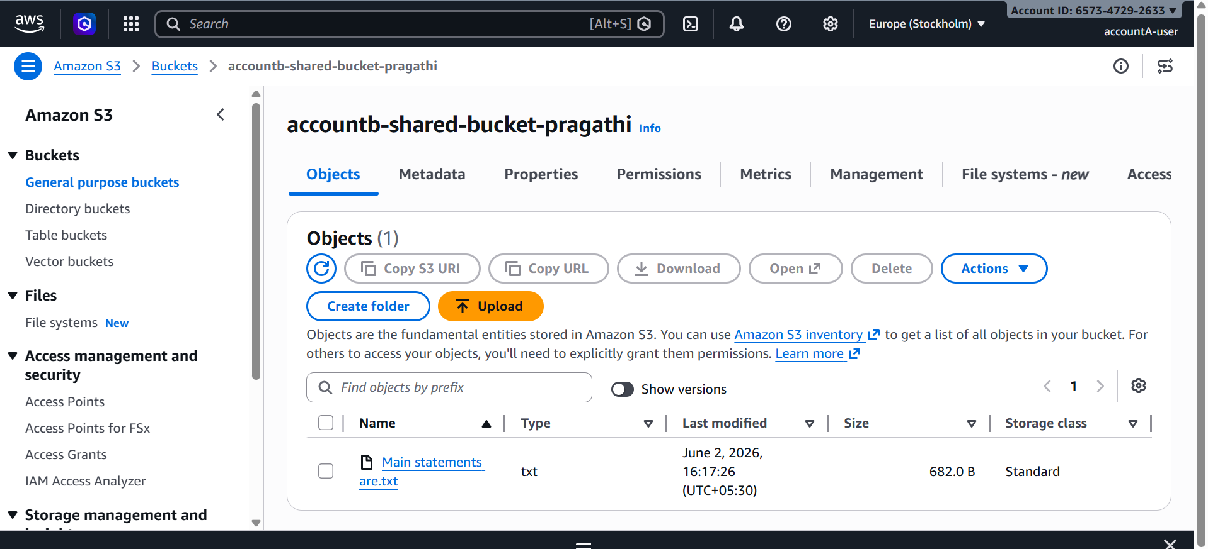
Step 6: Verify Access Using AWS CLI
Configure AWS CLI using accountA-user credentials.
List bucket contents:
aws s3 ls s3://accountb-shared-bucket
Expected Output:
test.txt
Download the file:
aws s3 cp s3://accountb-shared-bucket/test.txt .
Expected Output:
download: s3://accountb-shared-bucket/test.txt
Evidence Required
- Screenshot of successful bucket listing.
- Screenshot of successful file download.

Troubleshooting
Access Denied Error
Verify the following:
- Bucket policy is configured correctly.
- Correct AWS Account ID is used.
- IAM user in Account A has S3 permissions.
- Bucket name is correct.
- Object exists in the bucket.
Result
Successfully configured Cross-Account S3 Access between AWS Account A and AWS Account B. The IAM user in Account A was able to access and download objects from the S3 bucket located in Account B through a bucket policy, demonstrating secure resource sharing across AWS accounts.

